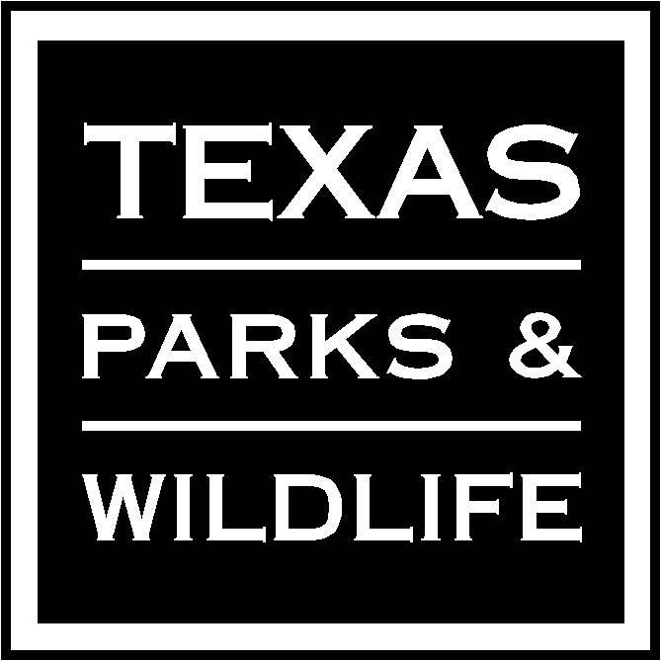 | Application Instructions for Wildlife Research Grant

FORMAT
Follow these instructions to complete the application for wildlife research (non-section 6). Use form PWD 1145A-W7000 for the text and form PWD 1145B-W7000 for the budget. You may use Microsoft Word and Excel 2003/2007/2010 or a different electronic format (PDF, WP, etc), provided the corresponding software reader is readily and freely accessible on the web. Whatever electronic format you use, the wording and sequence of each heading or category must be identical to those in the text and budget templates (PWD 1145A-W7000 and PWD 1145B-W7000).
The only acceptable sheet size is 8-1/2 x 11 inch with at least 1 inch margins suitable for printing on plain white paper in either portrait or landscape views. Fill this application form out completely by responding to each heading or category. Write "N/A" under each heading that is not applicable. Complete in English language only in 11 point Arial or Times Roman font.
The text should not exceed 10 pages. There is no preset maximum length limit per heading, category or section. However, additional supporting relevant attachments or addenda may be in included. Application materials will not be returned following evaluations and awards.
The complete budget and explanatory detail must be provided. We prefer the completed budget in Excel format so we can determine how you made calculations and more easily edit if accepted. Match the project title on the Excel budget form with narrative (text) title. Proposal text exceeding 10 pages plus the budget may not be reproduced for reviewers.
Addenda or Appendices. Include, as relevant, copies of principal investigator credentials, curriculum vitae, maps, publication lists, permits, private land access permission forms, collaborator letters of commitment, or other supporting documents. Note that if these materials have different page format sizes and non-gray scale colors may not be faithfully reproduced by reviewers’ printers.
Application Deadline: All applications, text, budget form and attachments must be received by TPWD as email electronic file attachments to (wildlife.research@tpwd.texas.gov) by midnight of January 15. Submissions after this date will not be accepted.
If total combined electronic file size exceeds 25 MB, please reduce size or parse and send as separate files. Do not compress the file because our server security systems may block them. We will send a confirming email within one business day after we have received your application.
PROPOSAL SUMMARY
Title: The title should be no more than 10 words all CAPS.
Principal Investigators (PIs): Include names of all PIs and co-PIs, in priority order, including titles, mailing addresses, telephone and fax numbers and email addresses. Curriculum vitae, relevant publication lists or other relevant credentials may be appended to this application.
Coordinating or Consulting TPWD Wildlife Division Employee (if known): Name(s) of the TPWD Wildlife Division employee that you prefer to act as Project Coordinator (PC) for this project. All TPWD-funded research projects must include a TPWD employee contact who will serve as first point-of-contact and advisor on all matters related to the project. This person will serve as co-author on any publications emanating from this research. Write “NA” if you have no preference and agree with TPWD assigning a PC for this project.
Partners or Collaborators: List names of known cooperating individuals, include organizations, USPS mail and email addresses. Section should include contributors of funding, equipment, supplies, work or other support (e.g. coordination, steering, review, quality control-quality assurance, etc). Include brief narrative detailing their relevant experience. Attach letters of commitment.
Target Species or Habitats: List target wildlife species, species of greatest conservation need or critical habitats that are the focus of this research effort.
Ecoregion(s) Affected: List any ecoregion(s) where this research will take place. See map at: www.tpwd.texas.gov/publications/pwdpubs/media/pwd_mp_e0100_1070s_08.pdf
River Basin(s) Affected: List any Texas river basins or watersheds where this research will take place or where inferences will be applied. See Texas River Basins, Major Bays and Streams map at: www.tpwd.texas.gov/landwater/land/maps/gis/map_downloads/images/pwd_mp_e0100_1070k_6.gif
Bay(s)/Estuary(ies): List bay(s) or estuary(ries) where the research will take place or where inferences will be applied. See map at: www.tpwd.texas.gov/publications/pwdpubs/pwd_pl_w7000_1187a/media/29.pdf.
Total Project Duration: List anticipated total project duration from contract approval to termination.
(Example: “November 15, 2011” through “August 31, 2013”)
Location(s): Where will the work be done, including any pertinent geographical data (e.g., state-wide, region, county, township, municipality)? Identify as explicitly as possible the bounds of the study area including amount and number of public and private property. Provide a map of location, as an attachment, if known.
- Site.or ranch name or street address if you have written landowner permission to disclose:
- County:
- Region, municipality, or township:
- Other description or information related to location:
PROPOSAL BODY
Introduction: Project justification and need. Cite specific priorities identified in any TPWD sponsored or cosponsored Plans including the 2011 Texas Wildlife Action Plan. Include a brief relevant literature review with cited references.
Objective(s): Specify explicitly what is to be accomplished given the time, money, and staffing requested. Objectives should be specific, measurable, attainable, relevant and time- and space-bounded. They should be clear, concise and directly related to the needs identified in the Introduction.
Hypotheses or Models to be tested: Based on the objectives above, formulate specific research theoretical, empirical and statistical hypotheses to be tested or model predictions to be validated. These should be clear, relevant and informative (i.e., nontrivial, not obvious or redundant).
Approach/Methods/Procedures: Develop research methodology for each hypothesis. How will the objective(s) be attained? Include experimental design. What assumptions and tests of assumptions will be made? Identify what the sampling or experimental units will be and how they will be selected. Identify minimum sample sizes and how those were derived. Identify any controls, treatments, replication and any potential sources of systematic error. Identify the parameters or attributes of the experimental units that will be measured, why those were chosen and how those will be measured. Include proposed statistical methods and assumptions and why those methods were chosen. Identify whether a pilot or trial phase will be conducted and if not, why not.
Expected Results or Benefits: What will be the anticipated management implication of accomplishing the objective(s)? What are the extent and limits of spatial and temporal inferences which will be drawn and what assumptions will be made? Define/detail what would constitute project success. What will be the measures of project success? What are the ramifications if the project is not conducted? What are the potential sources or risks of project failure? What is the outcome if the project fails? What contingencies can be put in place to mediate failure? You may include anticipated publications.
Literature Cited.
Timeline or Schedule of Activities and Deliverables: Include a chronological schedule of proposed activities, milestones, deadlines, reports and deliverables over the life of the project from contract approval to termination. It should include an annual performance report due by October 1 each year for federal aid reporting purposes. It should include individual responsible and date to nearest month when activity will be completed. If the project is large (multiple objectives and personnel) and long (> 3 years), include a spreadsheet, table or work breakdown structure of activities. Note that the timeline should provide a final performance report (may be in form of thesis or dissertation) before contract termination to meet TPWD federal aid obligations.
COMPLIANCE
Necessity and Ethical Use of Animals
TPWD is required to evaluate proposals on the basis of whether handling or care of wild animals is necessary and whether any harm may come to them during that time. Proof of compliance is required to comply with the Laboratory Animal Welfare Act of 1966 (“Act,” Public Law 89-544, as amended, 7 U.S.C. 2131 et seq.) pertaining to the care, handling, and treatment of warm-blooded animals held for research, teaching, or other activities supported by award assistance, Necessity and Ethical Use typically comes in to play when such animals are trapped and handled, as for marking or tissue sampling.
In addition the Health Research Extension Act of 1985 (PL 99-158) was enacted to insure the proper care and treatment of all vertebrate animals being used for behavioral or biomedical research. Thus the National Institute of Health provided guidelines (OLAW Public Health Service Policy on Humane Care and Use of Laboratory Animals and the Guide to the Care and Use of Laboratory Animals) that include vertebrate wildlife in free-ranging or natural state.
If the proposed research procedures will cause discomfort, distress or pain to vertebrate wildlife, then a copy of proof of compliance with the Act’s “Code of Federal Regulations, Title 9, Chapter 1, Subchapter A - Animal Welfare must be provided to TPWD research program coordinator by July 15 for projects beginning in the year following September 1. If we have not received the IACUC approval by July 15, that proposal may not be approved within one year following September 1.
If you have not marked one of the three (3) boxes on the application form, your application may be rejected.
Effects on Protected Class Species: Will any federally threatened or endangered species or their habitats be affected, impacted or handled?
If yes, include names of any federally listed threatened, endangered, candidate species which potentially may be affected by this research or its findings. What provisions will be taken to minimize impacts?
If handling endangered species, indicate your federal scientific collecting permit number. OR indicate if you will obtain a federal scientific collecting permit before contract approval.
Landowner Permission: Monetary awards are managed through state contracts with grantees. Any work to be performed on private lands in Texas using these funds requires, as a matter of state statute (TPW 12.103) and TPWD policy that grantees secure written permission from the private landowner(s) for the purposes of
- access to the land, and
- use of data collected on that land.
If your project will include reporting results from specifically identified private lands, written permission from applicable private landowners will be required before the contract can be approved by TPWD. Complete and attach form PWD 0153A-W7000 Landowner Permission for Wildlife Research including landowner(s) signature and date to this application packet, which demonstrates that they:
- have read, understood, and agreed to your proposal,
- will grant access to the land to specified individuals, and
- will grant permission to use data obtained from the project for scientific and/or environmental consultation purposes (e.g., reports, maps, databases).
OR
Provide Form PWD 0153a Landowner Permission for Wildlife Research will be provided later before contract approval.
(Note: if such action becomes necessary after the contract has been signed, then documentation, as specified above, will be required at that time).
PROPOSED BUDGET
This application is incomplete without an accompanying or attached proposed Budget using form PWD 1145B-W7000.
Estimate Annual and Total Project Costs: Include your estimated costs ($) per State of Texas fiscal year (September 1 - August 31) that are required to attain the Objective(s).
Use the following procedures:
- Identify costs in separate column headings as Amount Requested from TPWD, Applicant Share, and Partner Contributions, if applicable. A fillable, self-totaling, spreadsheet should simply the process. You will see that all the cells which calculate totals will be inactive from your end but will sum correctly once amounts are entered into corresponding cost categories. If proposal is approved, applicant must submit letters of commitment from each contributing partner prior to execution of a Contract.
- Provide and document any non-federal match in this application. The current non-federal match requirement is 25% or more. There is no extra credit for providing more than the minimum.
- If the proposal ranks high in need and technical aspects but insufficient matching funds are identified in the proposal, TPWD will discuss matching options with applicant. In such case, applicants will be given an opportunity to find qualifying match before the application is approved.
- To determine Non Federal Match options, applicants should contact their grants and contracts office to confirm appropriate eligible expenses. Performing agencies are required to claim the total project matching amounts on invoices to the Receiving agency.
- The entire match amount must be identified by source or the Performing Entity risks a proportionate reduction in the amount of federal funds awarded for this project.
- Performing Entity(ies) understand(s) and agree(s) that by accepting money for services for this Project, they must comply with all federal laws and regulations related to grants of federal funds. As part of this agreement, Performing Entity(ies) will be required to make the necessary certifications.
- Use the following cost categories, as applicable
  - Personnel: Separate salary from fringe benefits. Note brief justification if fringe benefits exceed 25%. Indicate the number of principal investigators, graduate students (MS and PhD), technicians or others and rates and duration of compensation received by year.
  - Travel: Lodging, mileage, meals, per diem (as appropriate) per individual. Travel-related expenses will be reimbursed at the official rate authorized by the State of Texas. Rates can be found at https://fmx.cpa.state.tx.us/fm/travel/travelrates.php
  - Equipment: Capital expenses for equipment to be used for project. Applicant must identify Capitalized and Controlled equipment (i.e., certain electronic items or ≥ $5,000 per item) to be purchased for this project.
  - Supplies: Costs for routine items needing replenishment throughout the project. Cost of materials and supplies will be reimbursed at their actual prices. Proper documentation will be required for reimbursement.
  - Subcontracted services: Expenses for services under contract with third parties; list names and contact information.
  - Miscellaneous: Items not listed above. Itemize and include justification
  - Total Direct Cost: The total of all items except administrative overhead.
  - Indirect Charges: Institutional administrative overhead; include rate as a percent (cannot exceed 15% of Total Direct Cost). Un-recovered indirect expenses based on the federally approved Indirect Rate may be used as a portion of Applicant's match. Note that the cells for Applicant and Partner Share (Non-federal Match) – Indirect Costs are open for you enter Unrecovered Indirect Costs which will vary by institution and Negotiated Indirect Cost Rate Agreements (NICRA).
  - Subtotal Total Costs by Fiscal Year: Sum of Request plus Match
  - Grand Total Costs for all Fiscal Years by Funding Source:
- If total TPWD project costs are = $100K then the performing agency may move up to 10% of category funds to other categories without prior TPWD approval. However, if total TPWD project costs are < $100K, performing agencies may not move more than 5% without prior approval.
- Equipment and supplies purchased shall be used, managed and disposed of in accordance with the Texas Uniform Grant Management Standards (UGMS).

