Coastal Fisheries Offices and Hatchery Locations |  | TEXAS PARKS AND WILDLIFE |  | Careers in Marine Biology, Fisheries and Habitat Management |  | Texas Parks and Wildlife | Coastal Fisheries Division
Coastal Fisheries Offices and Hatchery Locations |  | 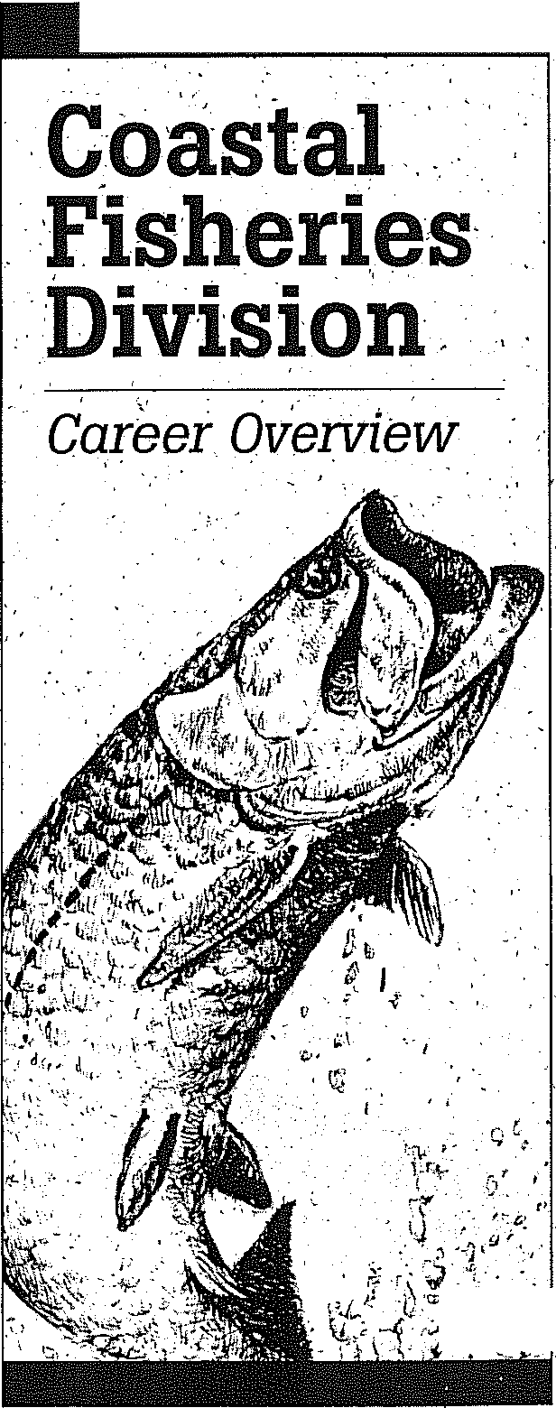
Headquarters Austin  Upper Coast Regional Office Dickinson  Galveston Bay Ecosystem Dickinson  Artificial Reef Program Dickinson  Lake Sabine Ecosystem Port Arthur  San Antonio Bay Ecosystem Port O'Connor  Matagorda Bay Ecosystem Palacios  Lower Coast Regional Office Rockport  Aransas Bay Ecosystem Rockport  Corpus Christi Bay Ecosystem Rockport  Upper Laguna Madre Ecosystem Corpus Christi  Lower Laguna Madre Ecosystem Brownsville  Sea Center Texas Lake Jackson  Perry R. Bass MFRS  Marine Fisheries Research Station Palacios.  CCA/AEP Marine  Development Center Corpus Christi |  |  |  | OCCUPATIONS  Fisheries | Marine Biology | Fisheries Management | Oceanographer | Wildlife Biologist | Ecologist  Environmental Scientist | Environmental Consultant  Aquaculture | Chemist | Biochemist | Statistician | Hydrologist | GIS Specialist |Human Dimensions Specialist  WORK ENVIRONMENT  Setting: Field stations, office, outdoor activities, coastal towns, Austin headquarters, hatcheries, laboratories.  Hours: Generally 8-5, but often involve longer hours, holidays and weekends.  Job Mobility: Usually employees remain at one location until a higher position becomes available. Forced transfers are uncommon.  Travel: Depends on the position, but some travel (other than for sampling) is possible.  Advancement Opportunities: Some positions are on Career Tracking. This means that you generally begin at the entry level and through time and performance you can advance to a higher position.  Future Outlook: Texas Parks and Wildlife (TPWD) jobs are always in high demand, and many people may apply for a single position. Consequently, the competition for jobs within the department is great. As the demand on our natural resources increases, so does the necessity for the continued collection of data in order to maintain the high level of sound management for which the Coastal Fisheries Division is noted. Good, qualified people are always needed to meet this challenge. |  | MINIMUM EDUCATION REQUIREMENTS  Technicians  High School Education or GED  Biologists & Specialists  Bachelor’s degree in fisheries science, biology, GIS or related field. This requirement varies with position and responsibility.  KNOWLEDGE, SKILLS AND ABILITIES  Important to Coastal Positions  Technicians  - Experience with boat and motor operation, maintenance and repair  - Experience with auto maintenance and repair  - Experience on the water  - Communication skills – written and verbal  - Familiarity with marine species and habitats  Biologists & Specialists  - Ability to write a scientific paper  - Training and experience with computers  - Training in statistical data collection and analysis and mathematics  - Training and experience in public speaking  - Ability to work with diverse groups of people  - Ability to weigh diverse input and make appropriate recommendations  - Knowledge of marine fish, fisheries and environments  Both Technicians and Biologists  - Ability to collect and summarize data  - Ability to understand and follow instructions  - Ability to work with people  - Ability to report and observe  - Ability to handle multiple assignments under unexpected and short deadlines  - SCUBA certification (required for some positions)  Note: Knowledge, skills and abilities requirements may vary significantly from position to position.
For more information, contact
Texas Parks and Wildlife
(800) 792-1112
www.tpwd.state.tx.us



4200 Smith School Road
Austin, Texas 78744

TEXAS PARKS AND WILDLIFE
MISSION STATEMENT:
To manage and conserve the natural and cultural resources of Texas and to provide hunting, fishing and outdoor recreation opportunities for the use and enjoyment of present and future generations.

DRAFT Document
BRIEF SUMMARY OF WORK ACTIVITIES |  | Biologists, Specialists and Technicians |  | EMPLOYMENT OPPORTUNITIES |  |  | TEXAS UNIVERSITIES
Collect, record, consolidate and analyze required data  - Assist in experimental design  - Assist in systems design  - Assist in quality control  - Conduct data analysis  - Conduct literature review  - Schedule activities  - Conduct data collection and research in field and laboratory setting including:  Field sampling activities: gill netting; bag-seines; bay and gulf trawls; special studies sampling; fish tagging; sport fishing interviews; commercial fishing interviews  Hatchery activities: water quality monitoring; feeding of fish; filter cleaning; spawn workup; data recording; spawning research; fish transporting; fish stocking  Laboratory research activities  - Genetics lab  - Age and growth lab  - Life history studies reef enhancement activities  - SCUBA diving on oil platforms and other artificial structures and natural reefs  - Working with oil companies to negotiate donations  - Population surveys of reef organisms  - Buoy maintenance  Supervise, schedule, counsel, train and hire assigned personnel  - Personnel administration  - Conduct performance reviews  - Conduct personnel conferences  - Conduct training  - Hire personnel  - Review time sheets  - Review travel vouchers  - Review training requests  - Develop daily, weekly and monthly schedules |  | Prepare verbal and written responses to requests by public  - Prepare follow-up memo to training and meetings  - Attend professional training course  - Attend professional meetings  - Demonstrate proper conduct toward the public and fellow employees  - Answer questions from the general public  - Respond to inquiries from legislators, commissioners, judges.  Prepare division reports  - Technical/scientific writing  - Routine technical reports  - Intra-agency reports  - Professional peer review journal publications  - Research proposal; (State, Federal Aid, Grants)  - Report review/editing  Maintain equipment and facility  - Perform routine preventive maintenance  - Perform equipment/facility repair  - Oversee equipment / facility repair  - Schedule maintenance  - Identify maintenance needs  Be familiar and comply with safety rules and procedures  - Follow all safety directives, memos, verbal direction.  - Attend safety training  - Wear appropriate safety equipment  - Notify appropriate personnel of safety problems or take corrective action  Administrative paperwork as required  - Maintain budgets  - Submit project needs  - Write equipment specifications  - Purchase necessary items  - Complete and review purchase orders and vouchers  - Complete and review routine administrative paperwork including:  - Time sheets  - Travel vouchers  - Personal training requests  - Personal monthly status reports  - Maintain vehicle logs  - Maintain vehicle maintenance reports  Increase public awareness of programs and activities  - Give presentations to the general public  - Give professional presentations  - Write news releases |  | TPWD advertises vacant positions which occur infrequently and competition is very heavy.  Occasionally there are student summer internships available. These provide a chance to work in the field, build on a résumé and see if this type of work interests you.  Non-paid volunteering, an alternative to the paid seasonal, is also an option at most field sites.  You can find out more about TPWD positions at our Web site: www.tpwd.state.tx.us and click on JOBS or call (800) 792-1112 ext 4485 |  |  | Texas A&M University and the University of Texas are Texas offer a marine science curricula.  Many other good colleges and universities with marine science programs exist throughout the country
 |  |  |  |  |  |  | ADVANTAGES OF THE JOB
- If you are in a field position, you get to work outdoors and on the water. You get to see nature at its best and its worst.
- You contribute toward the management and protection of Texas' marine resources.
- There is generally high Job satisfaction.
- You get to work with many different types of marine animals
- You get to work with many different groups of people.
 |  |  |  | VALUABLE COURSES OF STUDY AND TRAINING FOR YOUR CAREER
 |  |  |  | Technician Positions
 |  |  |  | Small engine repair | Trade skills such as:
 |  |  |  | Boating skills | - Electrical
 |  |  |  | Safety training | - Plumbing |  | DISADVANTAGES OF THE JOB
 |  |  |  | Outboard motor repair | - Carpentry |  | - Lots of paperwork  - Having to make difficult decisions that affect people’s lives  - Potentially strenuous outdoor activity  - Exposure to the elements  - Working in adverse and extreme weather conditions  - Occasional handling of venomous marine organisms
 |  |  |  | Navigation skills | - Painting
 |  |  |  | Geographical Positioning Systems | - Mechanic
 |  |  |  | Biologist & Specialist Positions
 |  |  |  | All biological sciences | English
 |  |  |  | General marine science | Mathematics including calculus and statistics
 |  |  |  | Oceanography | Mathematics including calculus and statistics
 |  |  |  | Aquatic ecology | Scientific writing
 |  |  |  | Wetlands ecology | Maritime law
 |  |  |  | Aquaculture | Chemistry
 |  |  |  | Botany | Geology
 |  |  |  | Animal Biology & Identification such as: | Computer and software proficiency
 |  |  |  | - Ichthyology | Geographic information system (GIS)
 |  |  |  | - Crustacea | Geographic information system (GIS)
 |  |  |  | - Mollusca | Human dimensions science

