2014 “Doing Business Texas Style” Spot Bid Fair
Information Packet

Event Details and Hotel Accommodations Page 2

Spot Bid Posting Information Page 3

Attachments: Bid Book Template Form (Microsoft Excel)
Save the Date Flyer
DIR Exemption Letter
TPASS Exemption Letter

- - - - - - - - - - - - - - - - - - - - - - Event Details - - - - - - - - - - - - - - - - - - - - - -
Date: May 12-13, 2014

Location: The Irving Convention Center
500 West Las Colinas, Irving, Texas 75039
http://maps.google.com/maps?daddr=500%20West%20Las%20Colinas%20Blvd,%20Irving,%20TX,%2075039,%20US
(Note: You may need to copy and paste this URL into your browser search.)

Time: Monday 1:30 p.m. to 5:30 p.m.
Tuesday 9:15 a.m. to 11:30 a.m. and resume from 1:15 p.m. to 3:30 p.m.

The Spot Bid Fair will close promptly at 3:30 p.m. State agencies and institutions of higher education are asked to turn in their (tentative) bid awards information to Tiffany Dockery no later than 4:30 p.m. A reception will be held following the Spot Bid Fair, and at which time the announcements of the (tentative) bid awards will be made periodically.

Registration: $350 per booth - includes one 6’ table; two chairs; and one ticket to enter all events.
http://events.constantcontact.com/register/event?llr=zfpx4zdab&oeidk=a07e8rwseoa57a4c821
(Note: You may need to copy and paste this URL into your browser search.)

Parking: May 13th - FREE of charge
May 14th - $5 per vehicle (Retain your parking ticket for re-entry.)

- - - - - - - - - - - - - - - - - - Hotel Accommodations - - - - - - - - - - - - - - - - - -
Location: The Holiday Inn Express and Suites Irving Convention Center – Las Colinas
333 W. John Carpenter Freeway, Irving, Texas 75039
Phone: 1-972-910-0302
http://maps.google.com/maps?daddr=333%20w%20john%20carpenter%20freeway,%20Irving,%20TX,%2075039,%20US
(Note: You may need to copy and paste this URL into your browser search.)

Cost: $84 per night - There are a limited number of rooms at this rate, so be sure to book your hotel accommodations as soon as possible. DFW Minority Supplier State Agencies Guests can call in at 972-910-0302 and request the DFW Minority Supplier State Agencies block rate when registering, or you can register online at:
http://www.hiexpress.com/redirect?path=hd&brandCode=ex&localeCode=en®ionCode=1&hotelCode=DFWJC&_PMID=99801505&GPC=MSS
(Note: You must copy and paste this URL into your browser search.)

Parking: FREE of charge (Self-Parking)

Other Hotels: A listing of state contracted hotels can be viewed on-line at via the State Travel Management Program’s webpage of the Texas Comptroller of Public Accounts.
http://www.cpa.state.tx.us/procurement/prog/stmp/stmp-hotel-contract/
(Note: You may need to copy and paste this URL into your browser search.)

- - - - - - - - - - - - - - - - Spot Bid Posting Information - - - - - - - - - - - - - - - -
2014 SENATOR ROYCE WEST
“DOING BUSINESS TEXAS STYLE” SPOT BID FAIR

The Texas Parks and Wildlife Department (TPWD) will host the online web portal for state agencies and universities to post their bid opportunities for “Doing Business Texas Style” Spot Bid Fair. The website can be found at: http://www.tpwd.state.tx.us/business/bidops/current_bid_opportunities/index.phtml

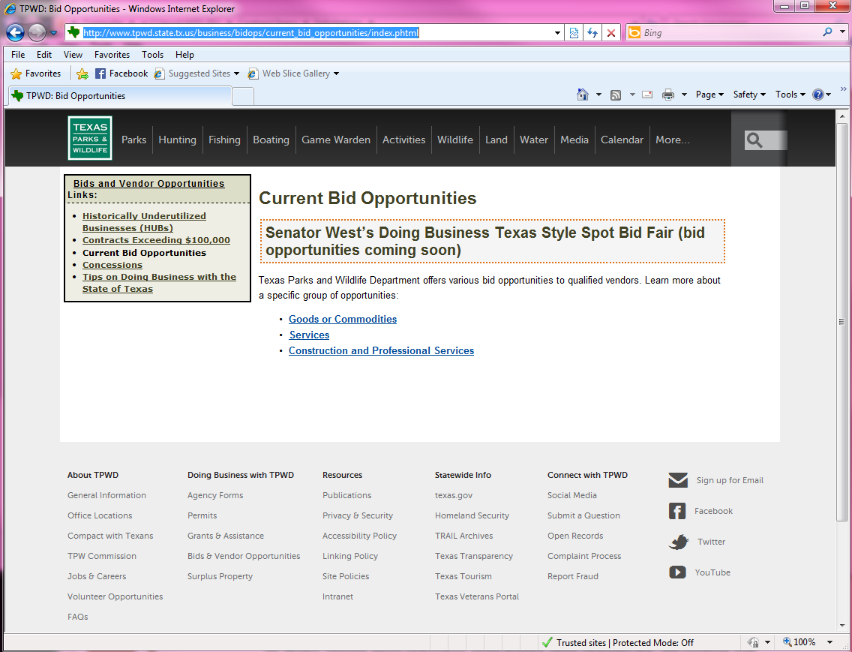

The web portal will include a statement informing prospective bidders that “Bid proposals will only be accepted in person at the Spot Bid Fair. Unless the contracting agency has specified a different bid closing time within the bid solicitation, the prospective bidders’ bid proposals must be received at the agency’s designated booth prior to 3:30 PM CT, on Tuesday May 13, 2014. Bid proposals that are faxed, mailed, or not received at the agency’s designated booth prior to the specified bid closing time on Tuesday, May 13, 2014, will be disqualified from the evaluation process.”

***** For the purposes of the Spot Bid Fair, agencies are strongly encouraged not to have its bid closing time prior to 3:30 PM CT, on Tuesday May 13, 2014. ****

Beginning Monday, March 3, 2014 through 5:00 PM CT, Tuesday, April 15, 2014 state agencies and universities may submit bid opportunities and solicitation documents for online posting to TPWD at purchasing@tpwd.texas.gov. TPWD will be responsible for submitting entries for the bid book for all bid opportunities received by April 15, 2014.

If your agency or university fails to submit bid opportunities and solicitation documents to TPWD by 5:00 PM CT, Tuesday, April 15, 2014:

- Complete the “Bidbook_template” spreadsheet in the prescribed format and submit via email to tiffany.dockery@austin.utexas.edu no later than 5:00 PM CT May 2, 2014. These opportunities will not be posted online, but will be included in the bid book.

- If bid book entries are not submitted by 5:00 PM CT, May 2, 2014, they will not be included in the bid book.

How to Submit Bid Opportunities and Solicitation Documents

Email Content:
- Bid packets (text file and PDF files) shall be emailed to TPWD at purchasing@tpwd.texas.gov
  - Email subject line shall identify: West Spot Bid Fair, Agency Name and Solicitation Number
  - Example: West Spot Bid Fair, Texas Parks and Wildlife, 802-14-84659
- Solicitation Numbers must be listed as: 3 digit agency number – FY – Solicitation Number
  - Example: 802-14-84659
- A text file must be attached for each solicitation submitted.
  - The text file name must be saved and submitted in the following format:
    - Agency number-Fiscal Year-Solicitation Number_text
    - Example: 802-14-84659_text
  - Text file shall identify the class and item number, solicitation number and a brief description of the bid opportunity.
Example: 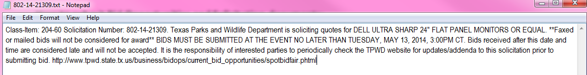

Solicitation Content:
- A sample Bid Fair Request for Quote (RFQ) is being provided as a tool. However, solicitations are not required to be submitted utilizing this template.
- Whether your agency/university chooses to use this sample template or another format, each solicitation MUST include the following:
  - Solicitation document cover page with
    - Soliciting Agency Name*
    - Purchaser’s Contact Information
    - Class/Item and Requisition number (Example: 204-60/ 802-14-84659)
    - Statement indicating bids will only be accepted in person at the event. Faxed or mailed bids will not be considered.

*Note: If your agency will not be present at the Spot Bid Fair, Texas Government Code Chapter 771
Chapter 771 provides authorization for agencies to “perform services” on behalf of other agencies pursuant to an agreement, which can be accomplished through an Interagency Contract (IAC). If the amount involved is less than $50,000, a written agreement is not needed between the agencies. If an agency will be accepting bid responses on behalf of your agency, make sure that information is clearly noted on the bid solicitation documents.

  - Solicitation Attachments: RFQ/IFB, specifications, drawings, agency terms and conditions and any additional attachments.
    - All documents must be submitted in PDF format and file names MUST be submitted in the following format: Agency Code-Fiscal Year_brief solicitation subject
        - All words after solicitation number MUST be separated by an underscore for proper loading to site
- Example: 802-14-84659_flat_panel_monitors.pdf
- If multiple PDFs are necessary due to size, clearly identify each attachment.
- Example: Attachment A_TPWD_terms_conditions
Please Note: TPWD is only responsible for posting bid opportunities and documents online. Each agency is responsible for bringing hard copies of their bid opportunities to the bid fair, proposal evaluation and contract award.
The submitting agency is responsible for ensuring that proper purchasing policies and procedures are followed. TPWD will not review bid documents for compliance purposes prior to posting.

