4th ANNUAL KID FISH
FORT PARKER STATE PARK

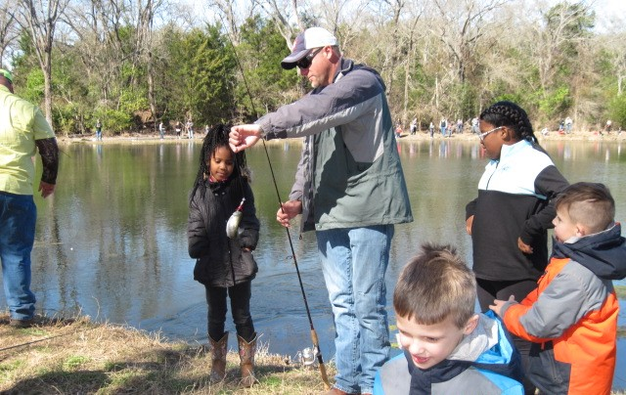

SATURDAY JANUARY 27th 2024
&
SUNDAY JANUARY 28th 2024

- Have fun casting, knot tying and catching Rainbow Trout!
- All equipment and bait are provided.
- All you need to bring is your family!

Saturday, January 27th (Ages 5-12)
9-11 a.m. 12-2 p.m. 3-5 p.m.

Sunday, January 28th (Ages 5-17)
1-3 p.m.

- Register your children now by calling Fort Parker State Park
Between 8:30 A.M. and 4:30 P.M. daily at (254) 562-5751

- Children 17 yrs. and under are free.

- Folks 18 yrs. and older are charged a $4 entrance fee.

Hosted by Friends of Fort Parker, Texas Parks and Wildlife Fisheries Division, and Fort Parker State Park!

