Biosecurity Protocols for the Cultivated Oyster Mariculture Program

- Hatchery and Seed Importation/Transfer Requirements

Out-of-state hatcheries can only be used if their products are certified as disease-free (Section 3) and of the proper genetic regional origin (Section 2). Out-of-state hatcheries will not be approved for use if they accept oysters from the Atlantic or Pacific coast – only hatcheries that work exclusively with Gulf oysters will be permitted. Hatcheries will not be approved for use if their culture system allows for the intermingling of Texas-bound product with water (effluent) from organisms from the Atlantic or Pacific Coast.
Each time seed is imported from an out-of-state hatchery, a signed copy of the Oyster Health Certificate (see Section 3) and an Oyster Transport Chain of Custody Form (TPWD form PWD1439F) must be provided to TPWD prior to seed importation. Written authorization from the Department must be received prior to the importation and stocking of diploid, triploid, or tetraploid larvae, seed or broodstock into Texas.
TPWD must be notified no later than seven (7) days before seed is imported, stocked, or moved from one permitted site to another. An Oyster Transport Chain of Custody Form must be submitted for all transport of oyster or seed between farms, hatcheries, and nurseries, except for transport to a Certified Dealer for sale. All intra-bay transportation of seed must conform to the broodstock region guidance below (Section 2).

- Guidance on Genetic Regions for Broodstock and Ploidy

There are two distinct genetic populations of Eastern oysters in Texas that overlap in the Corpus Christi/Aransas Bay estuarine systems (Anderson et al. 2014). This genetic distinction between populations must be incorporated into the management and use of seed oysters in Texas’ Cultivated Oyster Mariculture Program. For example, oyster seed produced from broodstock originating from the San Antonio Bay system northward can only be placed into bay systems north of and including Aransas Bay. Seed produced from broodstock originating from Corpus Christi Bay southward can only be placed into bay systems south of and including Aransas Bay. Oyster seed originating from the Aransas Bay system can only be placed in the Aransas Bay system.

Texas Diploid, Triploid/Tetraploid Oyster Importation Requirements

Oyster seed used in Texas oyster mariculture operations should come from Texas hatcheries using broodstock from Texas bays. If oyster seed from an out-of-state hatchery are to be used, they must be produced in a hatchery located along the Gulf of Mexico and be accompanied by diagnostic pathology/disease test results from a department-approved laboratory. See Texas Oyster Seed Disease Testing Requirements in Section 3.

- If permit holders purchase oyster seed produced from an out-of-state hatchery, the hatchery must utilize broodstock from waters associated with the appropriate Gulf oyster population (see specific population information below). Care must be taken to protect the genetic integrity of Texas oyster populations by ensuring oyster seed are placed into waters compatible with broodstock origin. Documentation of broodstock origin must be obtained from the hatchery and provided to the department prior to importation approval.
- Because of the known threat of introduction of MSX from oyster stocks grown in the waters of the Atlantic Ocean or drainages into the Atlantic Ocean, the sale of oyster seed, larvae or broodstock from Atlantic Coast waters is prohibited for use in Texas coastal waters.
- Because of the known threat of introduction of Oyster Herpes Virus (OsHV-1) from oyster stocks grown in the waters of the Pacific Ocean or drainages into the Pacific Ocean, the sale of oyster seed, larvae or broodstock from Pacific Coast waters is prohibited for use in Texas coastal waters.

Diploid Seed
To ship diploid seed oysters into the state of Texas the following is required:
- The TPWD Oyster Transport Chain of Custody (TPWD form PWD1439F), which includes the following application information:
  - Name / address of applicant (recipient; nursery or grow-out permit number);
  - Name / address of source facility (e.g. out-of-state hatchery);
  - Life stage (e.g. larvae, seed) and size (mm);
  - Quantity of each;
  - The seed destination (stocking site)
  - Geographic origin of all broodstock (Figure 1)
    - If broodstock was harvested by the permittee under a broodstock permit, the bay system, geographic coordinates, date, and number of broodstock organisms harvested should be reported, as well as the date the broodstock was sent to the hatchery for spawning
    - For diploid seed to be deployed in the northern Gulf estuaries of Texas (San Antonio Bay northward), broodstock must originate from Texas waters between the Louisiana state line to San Antonio Bay;
    - For diploid seed to be deployed in southern Gulf estuaries of Texas (Corpus Christi Bay south to Lower Laguna Madre) broodstock must originate from the southern Gulf of Mexico (Corpus Christi Bay to Lower Laguna Madre).
    - For diploid seed to be deployed in Aransas/Copano bay, broodstock can originate from either northern or southern Texas estuaries
    - Oysters from Aransas Bay can only be used as broodstock for seed that will be deployed in Aransas Bay – Aransas Bay oysters cannot be used as broodstock for activities in any other bay system.
            - Disease testing results (Oyster Health Certificate, see Section 3).

Triploid/Tetraploid Seed or Broodstock
To ship polyploid (3N or 4N) gametes, seed or broodstock into the state of Texas the following is required:
  - The TPWD Oyster Transport Chain of Custody (TPWD form PWD1439F), which includes the following application information:
  - Name / address of applicant (recipient; hatchery, nursery or grow-out permit number);
  - Name / address of source facility (out-of-state hatchery);
  - Life stage (e.g. larvae, seed) and size (mm);
  - Quantity of each;
  - The seed destination (stocking site)
  - Description of methods used to create the polyploid (e.g. tetraploid X diploid or chemical induction of triploid, etc.);
  - Ploidy (3N, 4N)
  - Ploidy testing results from a representative sample of seed purchased and description of how ploidy of seed was tested;
  - Geographic origin of broodstock for triploid seed
    - If broodstock was harvested by the permittee under a broodstock permit, the bay system, geographic coordinates, date, and number of broodstock organisms harvested should be reported, as well as the date the broodstock was sent to the hatchery for spawning
    - For triploid seed to be deployed in the northern Gulf estuaries of Texas (Louisiana state line to San Antonio Bay), triploid seed must be either (1) a cross between an established Gulf of Mexico tetraploid broodstock line and diploids from the northern Texas estuaries (Louisiana state line to San Antonio Bay), OR (2) a cross between northern Texas estuary broodstock diploids that have been chemically induced to the triploid condition;
    - For triploid seed to be deployed in the southern Gulf estuaries of Texas (Corpus Christi Bay south to Lower Laguna Madre), all broodstock must originate entirely from southern Texas estuaries (Corpus Christi Bay south to Lower Laguna Madre).
      - Triploids produced by crossing Texas diploids with tetraploids from the northern region or any other state cannot be used to stock farms in the southern Gulf estuaries (Corpus Christi Bay south to Lower Laguna Madre).
    - Triploid seed deployed in Aransas Bay can be either (1) a cross between an established Gulf of Mexico tetraploid broodstock line and a diploid from the either northern or southern Texas estuaries, OR (2) triploids produced entirely from broodstock originating in either northern or southern Texas estuaries
            - Disease testing results (Oyster Health Certificate, see section 3);

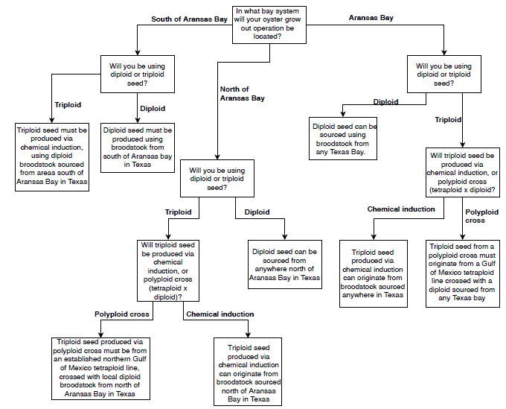

Figure 1. Flowchart of genetic regional requirements for ploidy, broodstock, and seed from an out-of-state hatchery

- Texas Oyster Seed Disease Testing Requirements

Shellfish that are to be imported from out-of-state and used for mariculture purposes must be tested for the following pathogens at a Department-approved laboratory (Table 1):
- MSX (Haplosporidium nelsoni)
- Dermo (Perkinsus marinus)
- Bonamiosis (Bonamia exitiosa)
- Oyster Herpes Virus (OsHV-1)

Each batch (same seed lot, same producer and held in the same environment) of oyster seed, larvae or broodstock brought into Texas for mariculture purposes must undergo two types of disease testing by a Department-approved laboratory (Table 1)
- Histological
- A representative sample (n = 60) of the seed, larvae or broodstock to be imported must be histologically processed, producing microscope slides showing all major tissue types.
ii. Slides must be read by an invertebrate pathologist.
iii. All findings of pathogens (MSX, Dermo, Bonamiosis and others) or commensals found within the tissue shall be reported.
2. Rays Fluid Thiglycollate Media (RTFM), PCR or qPCR
i. A representative sample (n = 60) of seed, larvae or broodstock to be imported into Texas must be tested for the presence of Perkinsus marinus (Dermo)
- Oyster Health Certificate
- An Oyster Health Certificate shall be submitted to TPWD for review and approval before oysters are shipped into Texas. The Oyster Health Certificate should include:
  - Dated and detailed pathology report, including the results for each pathology test, and a description of the methods used;
  - Name of the hatchery from which the seed originated
  - Certification case number
  - Certification date
- Only batches of oyster seed, larvae or broodstock found to have a light (under 10%) prevalence of Dermo and zero prevalence of other parasites or disease shall be approved for importation and introduction for mariculture purposes.
- An Oyster Health Certificate is valid for 30 days from the date of testing.

Facility | NC State Univ.-Center of Marine Science& Technology | Rutgers NJ Haskin Shellfish Research Lab. | Roger Williams Univ. Aquatic Diagnostics. Laboratory | FAU Harbor Branch Oceanic Institute | Virginia Institute of Marine Science
Address | 303 College Circle | 6959 Miller Avenue | 1 Old Ferry Rd. | 1 North | 1375 Greate Road
City | Morehead City, NC 28557 | Port Norris, NJ 08349 | Bristol, RI 02809 | Fort Pierce, Florida 34946 | Gloucester Point, Virginia 23062
Phone | 252-222-6312 | 856-785-0074 ex-4320 | 401-254-3299 | (772) 242-2525 | 804-684-7713
Contact | Dr. Tal Ben-Horin | Emily McGurk | Dr. Roxanne Smolowitz | Dr. Susan Laramore | Dr. Ryan Carnegie
Email | tbenhor@ncsu.edu | emily.mcgurk@rutgers.edu | rsmolowitz@rwu.edu | slaramo1@fau.edu | carnegie@vims.edu
Tests Required by TPWD | Tests Required by TPWD | Tests Required by TPWD | Tests Required by TPWD | Tests Required by TPWD | Tests Required by TPWD
Ploidy information | No | Yes | No | No | Yes
MSX (Haplosporidium nelsoni) | Yes | Yes | Yes | Yes | Yes
Dermo (Perkinsus marinus) | Yes | Yes | Yes | Yes | Yes
Bonamiosis (Bonamia exitiosa) | Yes | Yes | Yes | Yes | Yes
Oyster Herpes Virus (OsHV-1) | Yes | Yes | Yes | Yes, but not usually done | Yes, but not usually done
Table 1. Disease Testing Laboratories.

