NOTE: This application will not be considered unless fully completed and all required forms and documents are submitted. Prior to submitting this application, a site consultation with state agencies is recommended.

APPLICATION INSTRUCTIONS
There are two types of Cultivated Oyster Mariculture Permits (COMP), a Grow-Out Facility (Farm) permit and a Nursery-Only Permit. This application is used for both permits.
The application process should be considered a two-step process. Step 1 is to submit all the elements listed in Section 1 (page 4):
- Cultivated Oyster Mariculture (COM) Permit Application
- COM Operation Plan
- Natural Resources Survey of Proposed COM site
- Non-refundable COM Application Fee ($200)
Applicants are strongly encouraged to coordinate with Texas Parks and Wildlife Department (TPWD) before completing the natural resource survey and COM permit application. During this pre-application coordination, TPWD will evaluate your proposed site using the department’s Spatial Planning Tool (SPT), which can help avoid investing effort into a site that may be denied during the permitting process.

Before submitting your application make sure you have answered all questions in Section 1 of the application and all sections of the Operation Plan. Failure to do so may result in significant delays in processing time.
- Please write legibly.
- Answer all questions clearly and in detail.
- If a question does not pertain to your proposed operations, please write “not applicable” or “NA.” Leaving questions blank will result in processing delays.
- Please label all maps, diagrams, and images according to the instructions provided.
- Please make sure your name appears on every document that’s submitted as part of your application packet.
- If you have questions about the application or leasing process, please email us at oyster.mariculture@tpwd.texas.gov

Upon receipt of these documents and fee, an opportunity for public comments regarding the proposed oyster mariculture site will be made available through the posting of site-specific information on the TPWD web site and a public meeting held in the municipality closest to the proposed site. After the review and consideration of public comments, applicants will be issued a Conditional Permit that authorizes them to proceed to the second step in the application process.

Step 2. Once you have received a Conditional Permit, you can proceed with Step 2. Please contact the agencies listed below to obtain any required permits, leases, and/or written approvals for conducting oyster mariculture activities. Failure to proceed in this order could result in additional permitting costs to the applicant.
Texas General Land Office Permitting Assistance
- Upper Coast Applicants (north of Colorado River)
409-741-4057 / 866-894-7664 (Toll Free)
- Mid and Lower Coast Applicants
361-886-1630
Permitting.assistance@glo.texas.gov
Programmatic Questions
Danielle DeVacque
Danielle.DeVacque@glo.texas.gov
361- 886-1605
Texas Commission on Environment Quality
Wastewater Mónica Vallin-Báez
Industrial Wastewater Permits Team
Water Quality Division
512-239-5787
Monica.baez@tceq.texas.gov
Water Rights Chris Kizlowski
Water Rights Permitting Team
Water Availability Division
512-239-4691
Chris.kozlowski@tceq.texas.gov
Texas Department of State Health Services Seafood and Aquatic Life Group
Seafood.Regulatory@dshs.texas.gov
512-834-6757
Texas Department of Agriculture Larry Mitchell
Coordinator for Grain Warehouse, HMPC and Aquaculture
Lawrence.mitchell@TexasAgriculture.gov
512-936-2430
U.S. Army Corps of Engineers General Number: 409-766-3869
Upper Coast Field Station:
Kristi McMillian
Kristi.N.McMillian@usace.army.mil
409- 766-3083
Lower Coast Field Station:
Matt Kimmel
Matthew.L.Kimmel@usace.army.mil
361-814-5847

U.S. Coast Guard Timothy Boriskie
Private Aids to Navigation
D8oanPATON@uscg.mil

When you have acquired the appropriate permit, lease and/or other written authorization from each of the above agencies that are listed in Section 2, please submit electronic copies of each to Texas Parks and Wildlife Department’s Oyster Mariculture Program. Once the department has reviewed the complete application submission, applicants will be notified, in writing, of their permit approval and provided a copy of the permit, permit conditions and permit boat plates.
The first year’s annual permit fee will be due at this time. For grow-out activities occurring in public water, the fees will be $450 per acre per year. For grow-out activities occurring on private property, the fees will be $170 per acre per year. For the Nursery-Only permit on private property, the fees will be $170 per acre per year. For Nursery-Only permit activities occurring in public waters, there will be a surcharge of $0.01 per square foot per year ($435.60 per acre per year).

APPLICATION SUBMISSION CHECKLIST

Please note: This checklist is provided for the applicant’s reference and does not need to be returned with the application.
- Content
Check for non-refundable application fee ($200), payable to Texas Parks and Wildlife Department.
Operation Plan (see Appendix A for guidance)
One (1) Vicinity map with required items shown, containing a drawing of the site boundary.
_____ One (1) Access Route map, showing the access route to the site (can be combined with Vicinity Map)
_____ One (1) “Site Layout” Map, with an overhead view depicting the layout of the gear across the proposed site
One (1) Gear drawing for each type of gear proposed.
One (1) Overhead view depicting layout of gear from overhead.
One (1) Cross-section view depicting gear and moorings from the side for each gear configuration.
Names and addresses of adjacent property owners.
Summary of Findings from Natural Resource Survey (see Appendix B)

- Formatting
All pages (including attachments) are numbered sequentially.
All attachments are clearly labeled and legible.
Drawings and maps are legible, labeled properly, and include all required elements.
All questions have been answered and signature page signed.
Please do not staple applications.

SECTION 1.
- APPLICANT INFORMATION
Effective September 1, 2015, Texas Parks & Wildlife is required to collect Social Security numbers for the purpose of child support enforcement under the Texas Family Code, Section 231.302 and Federal Statute 42 U.S.C. §666. Missing or incomplete information may delay application processing time.
Texas Parks and Wildlife Department maintains the information collected through this form. With few exceptions, you are entitled to be informed about the information we collect. Under Sections 552.021 and 552.023 of the Texas Government Code, you are also entitled to receive and review the information. Under Section 559.004, you are also entitled to have this information corrected.
Name: _____________________________________ Social Security #:______________________
Date of Birth : _______________________________
Address: ____________________________________________________________________________
Street City State Zip
Email: ________________________________________ Primary Phone: (_______) _______-________
Driver’s License #: __________________________ Driver’s License State ____________
This application is for (check one of the following):
________ Cultivated Oyster Mariculture Grow-Out Facility (Farm)
________ Cultivated Oyster Mariculture Nursery-Only Facility
Please Check all that apply. This facility will be located on:
____ Private Land _____ In public waters ___ Both
Facility Name (business name): ______________________________________________________________
Facility address: (For a grow-out facility, the physical address would be the latitude-longitude coordinates. A nursery operation should have a physical address, even if associated with an upweller on a barge tied to a pier (e.g. address of the property).
___________________________________________________________
Street City Zip Code County.
SIGNATURE: I hereby affirm that all of the information provided above is accurate and complete and that I have read the rules pertaining to Cultivated Oyster Mariculture, including:
- 31 TAC Ch. 58 Subchapter F: (https://texreg.sos.state.tx.us/public/readtac$ext.ViewTAC?tac_view=5&ti=31&pt=2&ch=58&sch=E&rl=Y)
- Parks and Wildlife Code Chapter 75: (https://statutes.capitol.texas.gov/Docs/PW/pdf/PW.75.pdf)
- TPWD COM Program Requirements
- TPWD COM Biosecurity and Disease Certification Protocols
I understand that under Texas Penal Code §37.10, it is a felony to make a false statement on this form

__________________________________________ _____/_____/_____
Signature of Applicant Date

- Operation Plan
An Operation Plan is required to be submitted as part of the application process. This plan should describe the details of the mariculture operation including site location and layout, type of gear to be used, seed source and operational details. The Operating Plan template can be found in Appendix A.
- Natural Resources Survey
The Natural Resource Survey is designed to verify that the proposed permit area does not contain sensitive habitat such as seagrass, oyster habitat, etc. Survey protocols and required deliverables can be found in Appendix B.
Which Natural Resources survey did you complete? Please Check One:
____ Sidescan Sonar with Ground-Truthing ____ In-Situ (Grab Samples) Only

SECTION 2.
NON-TPWD AGENCY COORDINATION
Final authorization of the Cultivated Oyster Mariculture (COM) Permit is contingent upon receiving the appropriate permits, leases and/or written authorization for oyster mariculture activities from the following agencies:
- Texas General Land Office (Submerged Lands Lease):
Lease No.
- Texas Commission on Environmental Quality – wastewater (Completed and signed Notice of Water Quality Authorization under the Aquaculture General Permit TXG13000)
- Texas Commission on Environmental Quality – water rights (Completed and signed Exempt Mariculture Operation Form, If applicable)
- Texas Department of State Health Services
Training Certification No.
- U.S. Army Corps of Engineers (Nationwide 48 or General Permit for Shellfish Aquaculture)
Permit No.
- U.S. Coast Guard Private Aids to Navigation Marking Determination
These documents should be obtained after the Conditional TPWD COM Permit is issued but will be required before the Final TPWD COM Permit is issued. Copies of these approval documents must be submitted to TPWD as part of the application process. Once all appropriate approval documents have been received, the department will notify the applicant regarding the final execution of the permit. Annual permit fees will be due upon final execution of the permit.

Annual Permit Fees
- Grow-out site - $450 per acre
- Nursery site - $170 per year + $0.010 per square foot for nursery operations located on public waters.
SIGNATURE: I hereby affirm that all of the information provided above is accurate and complete and that I have read the rules pertaining to Cultivated Oyster Mariculture (31 TAC Ch. 75; available by mail upon request or online at http://texreg.sos.state.tx.us/public/readtac$ext.ViewTAC?tacview=5&ti=31&pt=2&ch=75&sch=C&rl=Y).
I understand that under Texas Penal Code §37.10, it is a felony to make a false statement on this form

__________________________________________ _____/_____/_____
Signature of Applicant Date

Please return completed application to:
Coastal Fisheries
Texas Parks and Wildlife Department
4200 Smith School Road Austin, Texas 78744.

To process your request more efficiently, you may email completed forms to
oyster.mariculture@tpwd.texas.gov

Texas Parks and Wildlife Department maintains the information collected through this form. With few exceptions, you are entitled to be informed about the information we collect. Under Sections 552.021 and 553.023 of the Texas Government Code, you are also entitled to receive and review the information. Under Section 559.004, you are also entitled to have this information corrected. For assistance call 512- 389-8119.

Appendix A

Cultivated Oyster Mariculture Operation Plan

Please include the following information on all attachments submitted with your permit application:

Name/Business: Your name
Town, State: Your town, TX
Contact Phone Number
Waterbody: Name of Bay
Date: Current date

The Cultivated Oyster Mariculture (COM) Operating Plan must be submitted with your Texas Parks and Wildlife Department COM Application.

Before submitting your Operating Plan make sure you have answered all questions. Failure to do so may result in significant delays in processing time.
- Please write legibly.
- Answer all questions clearly and in detail.
- If a question does not pertain to your proposed operations, please write “not applicable” or “NA.” Leaving questions blank will result in processing delays.
- Please label all maps, diagrams, and images according to the instructions provided.
- If you have questions about the application or leasing process, please contact TPWD at oyster.mariculture@tpwd.texas.gov.

Site Information
County: ___________ Closest Town:____________________
Waterbody (Bay System):_______________________
Texas Department of State Health Services (TDSHS) Shellfish Harvest Areas and Designation (Harvest Area can be found on the TDSHS website https://dshs.texas.gov/seafood/shellfish-harvest-maps.aspx)*: TX-
*Grow-out operations will only be permitted in areas designated as “Approved” or “Conditionally Approved” by the TDSHS.

- Vicinity Map
Attach an accurate 8-½ by 11-inch map of the site with a background of either the County Appraisal District map, NOAA chart, aerial imagery (Google Earth Image), or topographic map, with a maximum scale of 1:24,000 (USGS Quad Sheet). The Vicinity Map should show the location of the proposed permit area and the surrounding waters and adjacent properties. Mark the entire boundary, including the corners, of your proposed permitted area on the map, ensuring that the area is easy to identify. See example pages.
Please list the corner coordinates of the proposed lease area using decimal degrees (01.23456) and provide the datum (e.g. NAD 83, WGS 84, etc.). Coordinates should be provided to 5 digits to the right of the decimal.
1. _________________________ N, _________________________W
2. _________________________N, _________________________W
3. _________________________N, _________________________W
4. _________________________N, _________________________W
Additional Corner Coordinates (if more than 4):
5. _________________________N, _________________________W
6. _________________________N, _________________________W
7. _________________________N, _________________________W

Total Acreage Requested:
_______ Private Property _________Public Waters ____________Total
- Access Route Map
Attach an accurate 8-½ by 11-inch map of the site with a background of either the County Appraisal District map, NOAA chart, aerial imagery (Google Earth Image), or topographic map, with a maximum scale of 1:24,000 (USGS Quad Sheet). The Access Route Map should have the planned access route to the site clearly drawn. *** If the access route is included on the Vicinity Map, a separate Access Route Map is not required***

*Is the access route displayed on the Vicinity Map? ____Yes ___ No

For Nursery locations, please include directions to the proposed site in the footer of the Access Route Map. Please provide directions to the site from a known location or landmark. Include highway and street numbers as well as names. Also provide distances from known locations and any other information that would assist in locating the site.

- Site Layout Map: 1) Overhead AND 2) cross-section view of Permitted Area showing your maximum gear layout.
For overhead view, include:
      - Maximum gear array, including moorings;
      - Length and width of project area.
      - Approximate spacing between gear.
      - Permitted area boundaries, location of proposed corner markers and any additional gear markers that may be used, and distance from nearest shore.
For cross-sectional view, include:
- Profile of gear in cross-section as it will be deployed;
- Gear dimensions with units (e.g. 10in, 10-ft, etc.)
- Show mooring gear with type, scope (length), hardware, and line type and size (diameter);
- Location of gear in relation to water’s surface at mean low water (if applicable).
Note: Please include an additional cross-sectional view, depicting the elements above, if there will be seasonal changes to gear layout, including any temporary gear submersion activities during hurricane events.

Site Development
- Gear Information
  - Gear drawing/photo: Top and cross-sectional view of each gear type (e.g. cages, nets, trays, containers, etc.) that will hold oysters in your permitted area. If gear is to be purchased, please provide the brand and model number of each piece of gear provided. See example pages.
  - Gear table: List and describe each individual gear type that you will use in the table below (e.g. cages, bags, trays, moorings, mooring lines, buoys, etc.). You should have one entry for each drawing/photo provided in section a above. Add additional pages if needed and attach to this section.
Specific Gear Type | Dimensions  (e.g. 9”H x 40.5” W x 67.5” L) | Time of year gear will be deployed  (e.g. Spring, Winter, year-round, etc.) | Maximum amount of this gear type that will be deployed on site at any given time  (e.g. 200 cages, 100 buoys, etc.)

OPERATIONS

Directions: If a question does not pertain to your proposed operations, please write “not applicable” or “N/A.” Please use additional sheets if necessary and attach with this section.
Question 1 – Please describe how the gear presented the Gear Table is configured and operated. E.g. how do buoys, anchors, and cages attached to mainline? If using floating cages, are bags inserted into cages, etc. This information can be supplemented by product brochures describing the operation of the gear.

Question 2 - Please describe your proposed tending/maintenance and harvesting activities (i.e. elevating or flipping cages, methods for cleaning cages or raceways, tumbling, sorting and harvesting, etc.). Please be sure to include the following information : if gear will be tended from boat or by wading, the frequency with which you will visit the site for routine tending/maintenance (e.g. elevating or flipping cages, cleaning cages, tumbling, sorting, etc.) and how frequently you will visit the site for harvesting. Finally, please describe how you will comply with current pre-harvest re-submersion stipulations. Use additional pages, if necessary.

Question 3 – Please describe how gear will be tagged. What material will be used and how will tags be affixed to the gear?

Question 4 - Please explain your proposed seeding/stocking activities. What months will seeding/stocking occur and how often do you anticipate being onsite during this time? What quantity of seed are you planning on stocking and how often?

Question 5 - Please provide information about the expected source of oyster seed to be cultivated. Include name and address of source hatchery or hatcheries. Include the bay system of origin of the broodstock. Please include whether you will be using diploid or triploid oysters; If using triploids, please note the method of triploid creation (induction or cross with tetraploid). If the hatchery does not currently have the broodstock, please describe how the broodstock will be collected and sent to the hatchery. If the seed is coming from an out-of-state hatchery, where will it be sent for pathogen testing?

Question 6 – Please describe your response plan if disease is identified in your farm. What will be done with diseased oysters? Note; if disease conditions other than dermo are identified within the farm, TPWD must be notified within 24 hours.

Question 7 – Please describe your plans for the sale of your product. Do you plan on selling to a Certified Shellfish Dealer, or will you be seeking a wholesale certification license from the TDSHS for the direct sale of your product?
Checkbox: _____ Sell to a Certified Dealer ____ Direct Sale

Question 8 – How will you access the proposed site? If from the adjacent shore, please describe how you will avoid negative impacts to sensitive shoreline habitats (if present). Please provide an aerial map showing site access as shown in “Site Information – Examples”.

Question 9 – How will your proposed activities affect ingress and egress of adjacent property owners? How far is the proposed site from the emergent shoreline?

Question 10 – Please provide details of your Hurricane/Tropical Storm Plan. Plan should include management details for the protection of all equipment and oysters within your permitted area beginning 72-hours before projected landfall. Plan should include what specific factors will be considered when deciding to execute the plan (e.g. what triggers will be used for sinking the cages? Hurricane Category, Cone of Impact, Etc.)

Question 11. Please describe any predator or bird deterrents you will use. How do you plan to mitigate or minimize the potential pollution impact of birds? Predator deterrents should also be included in the gear list and gear drawings. Note – only deterrents that are listed and approved in the operations plan will be allowed; a permit amendment will be required for additional predator deterrents.

Question 12. Please describe the gear (buoys, anchor, line, pilings, etc.) that will be used to demarcate the site boundary.

Question 13 (Nursery-Only Permit): Please describe how surplus oysters that are not sold will be disposed of. This includes any oysters greater than 1” in length that are not sold. Note – oysters greater than 1” in size are prohibited in a nursery operation.

ADJACENT PROPERTY OWNER’S LIST
Please provide a list of the names and addresses in the table below, as shown on the latest county tax assessment roll, of each adjacent property owner within 2,000-feet of the proposed oyster mariculture site.
Lot No. | Name | Address

Please use additional sheets if necessary and attach here.

Site Information Examples
The following are examples of the various diagrams that must be included in your Operation Plan. These diagrams can be hand-drawn on separate sheets of paper but must be legible.
Please include this information on all attachments submitted with your application:
  - Your Name/Business:
  - Your city, county and State
  - Contact phone number
  - Waterbody/Bay System
  - Current Date

SITE INFORMATION:
- Examples
  - Example 1: Vicinity Map
      - Corner numbering should start at the NW most point and move in a clockwise direction. Number designation here should also be consistent with your cross-section diagrams.
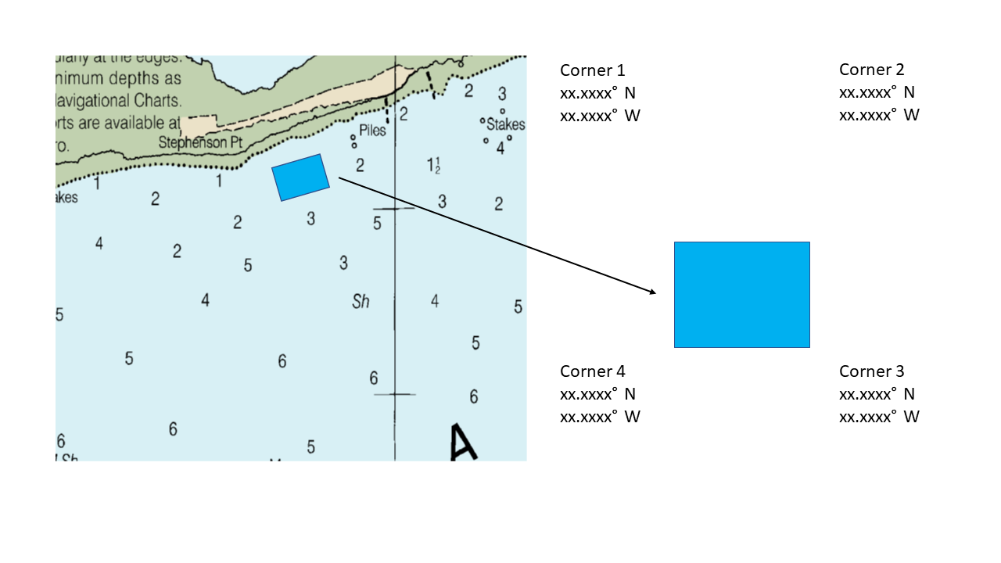

  - Example 2: Access Route Map
      - An example of a site map showing the proposed access route. Note how the access route is planned to avoid tidal flats, salt marshes and seagrasses that are in the vicinity (to the northwest) of the site. The impact to natural resources within the site footprint and along the access route will be reviewed for each proposed site. ** If the access route is included on the Vicinity Map, a separate Access Route Map is not required.
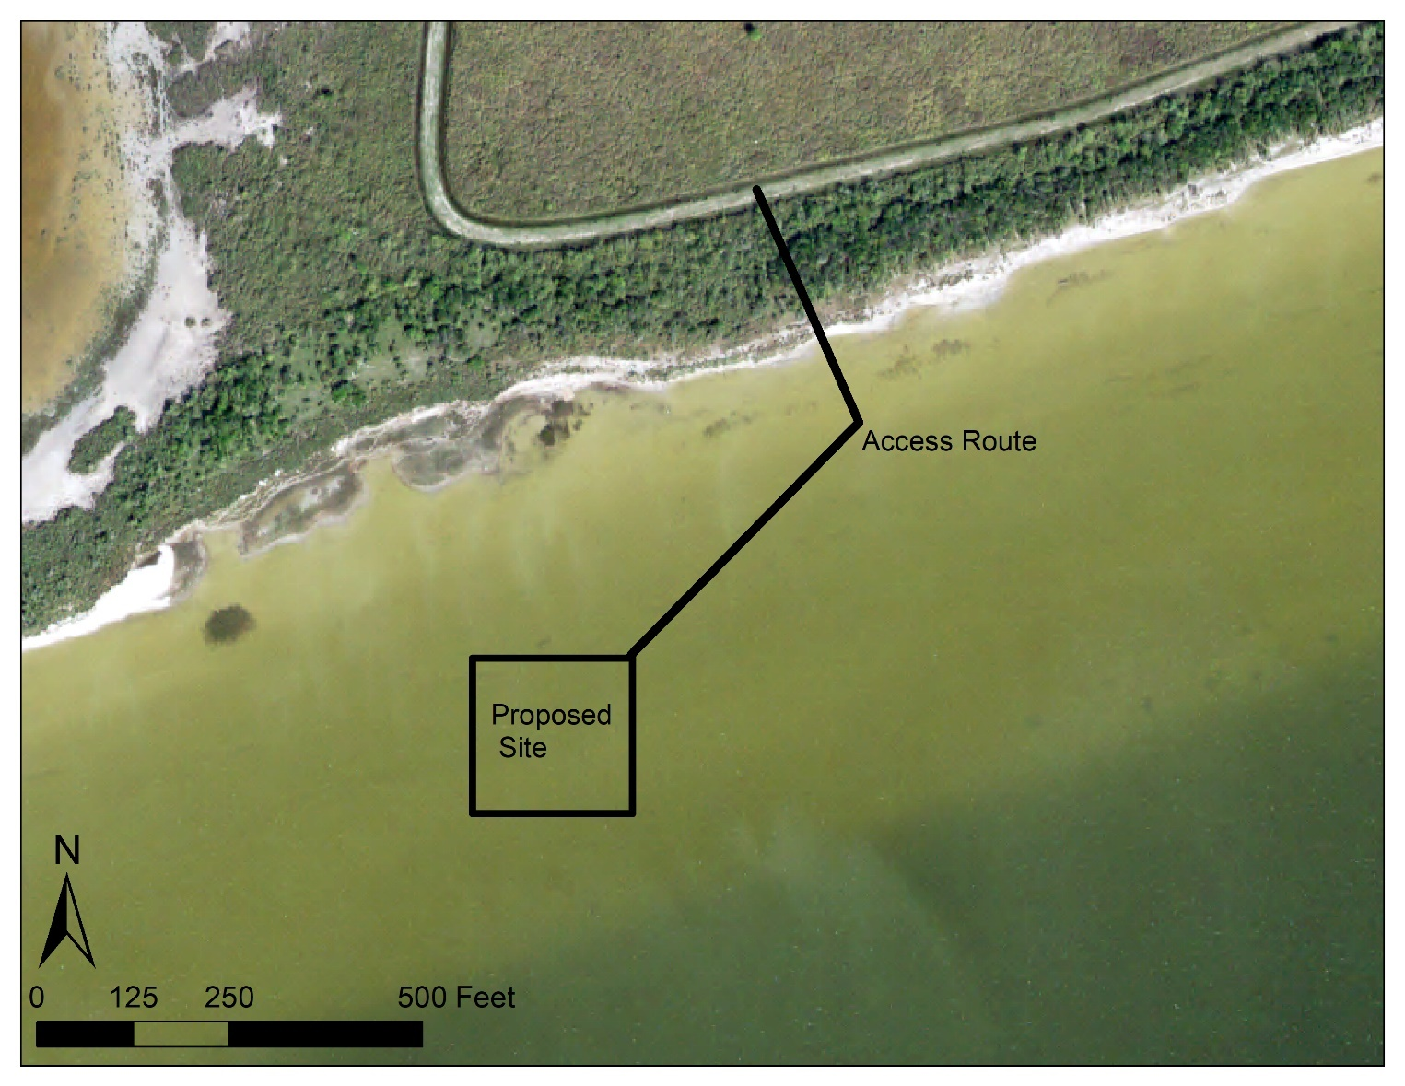

- Example 2: Site Development and Gear Information

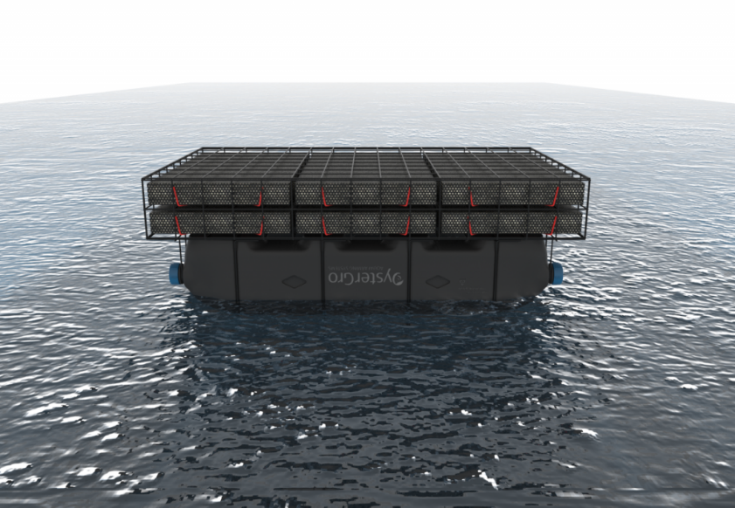
OysterGro® ProFlo™ Cage

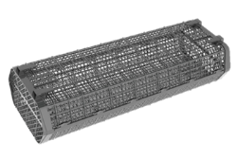
Hexcyl Adjustable Long Line Basket

- Example 3: Site Layout Map: Overhead View *Note how the “maximum” gear array is displayed, and not a subset of the proposed site.
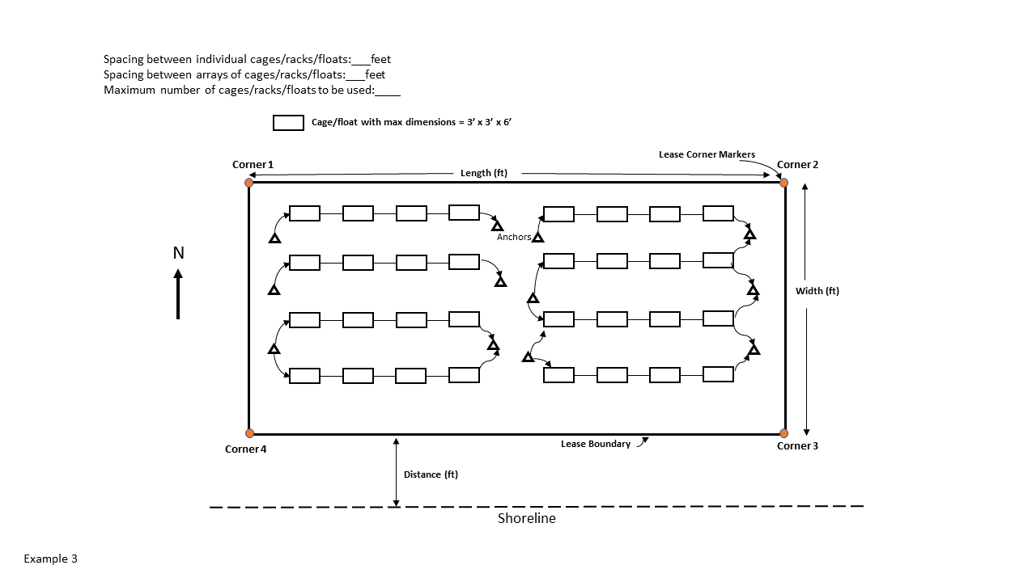

- Example 4
Example 4a - Cross-sectional view, constant water depth with cages or floats

See application for detailed equipment descriptions, spacing and layout measurements
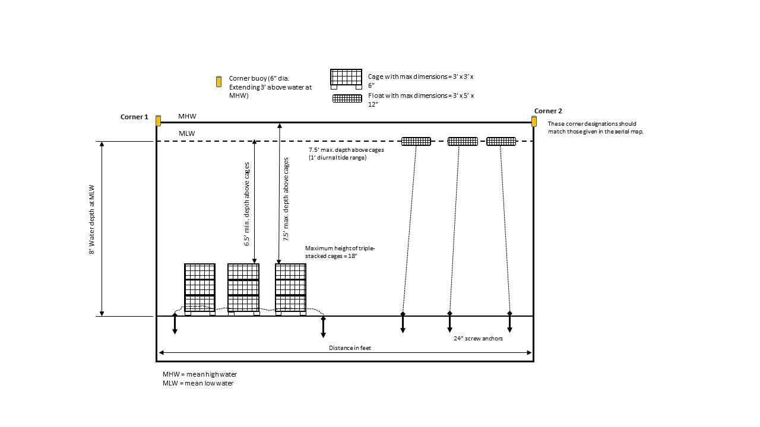

  - Example 4b - Cross-sectional view, adjustable long line system
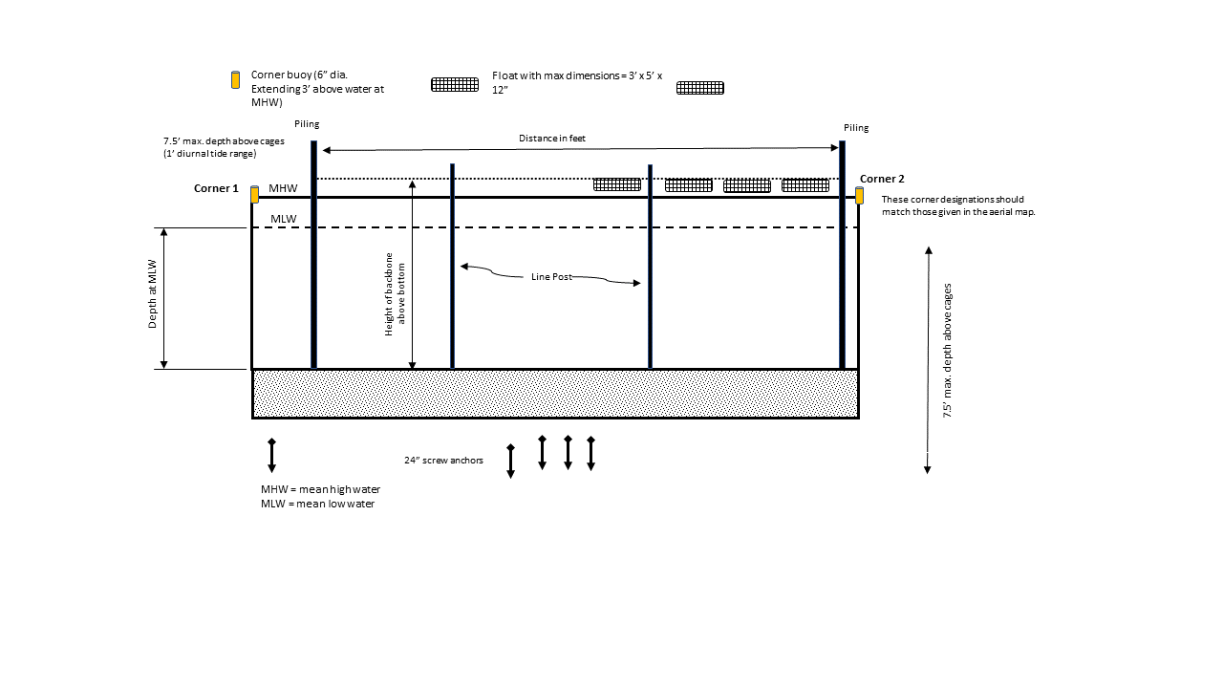

Appendix B
  - Commercial Oyster Mariculture Natural Resources Survey Protocols

Introduction

Survey purpose
The purpose of the natural resources survey is to ensure no sensitive habitats or natural resources will be negatively impacted by Commercial Oyster Mariculture operations. Sensitive habitats include seagrasses, oysters, and other biogenic reef (Rangia, serpulid, etc.), as well as intertidal habitats such a saltmarsh, mangroves, and tidal flats. Natural resources include areas that are essential for fish and wildlife species, such as bird rookeries, designated Threatened and Endangered (T&E) species critical habitats, and protected conservation areas.
Applicants are strongly encouraged to coordinate with Texas Parks and Wildlife Department (TPWD) before completing the natural resource survey and COM permit application. During this pre-application coordination, TPWD will evaluate your proposed site using the department’s Spatial Planning Tool (SPT), which can help avoid investing effort into a site that may be denied during the permitting process.

To minimize impacts to sensitive habitats, the following buffers have been established:
- 200-feet for seagrass habitat;
- 500-feet for oyster habitat;
- 2,000-feet for bird rookeries
Additionally, sighting of proposed COM sites should avoid the presence of serpulid reefs within the proposed area and permitted areas that are to be accessed from shore should include measures within the Operating Plan to minimize impacts to sensitive shoreline/marsh habitat.
The field survey (to be completed by applicant) will ONLY investigate the presence of seagrass and oyster habitats. The remainder of the sensitive habitats and natural resources will be evaluated by TPWD staff using their Spatial Planning Tool.

Habitat definitions
“Seagrass habitat” is defined as the presence of above-ground or below-ground (rhizome) biomass of any of the 5 species of seagrasses that occur in Texas, including Shoalgrass (Halodule beaudettei), Widgeongrass (Rupia maritima), Manatee grass (Syringodium filiformes), Turtle grass (Thalassia testudinum), and Star grass (Halophila engelmanii). In a grab sample survey, this would be any sample that has rooted seagrass material present. In a sidescan survey, this would be any feature that is visible in the imagery where in-situ grabs confirm the presence of rooted seagrass – in this case, the entire seagrass feature would be avoided using a 200’ buffer. Using TPWD’s Spatial Planning tool, this habitat definition also includes any seagrass habitats that have been identified in the past 20 years by accurate mapping efforts. If seagrass is present at a single sampling location, that location should be avoided with a 200’ buffer.
“Oyster habitat” is defined as the presence of live oysters OR the presence of consolidated oyster shell substrates OR shells greater than 25 mm. In a grab sample survey, this would be any sample that is dominated by shell substrates, or contains shell fragments greater than 25 mm. In a sidescan survey, this would be any feature that is visible in the imagery where in-situ grabs confirm the presence of shell material – in this case, the entire oyster feature would be avoided using a 500’ buffer. Using TPWD’s Spatial Planning tool, this habitat definition also includes any oyster habitats that have been identified in the past by accurate mapping efforts. Live oysters do not need to be present in order to define the area as “oyster habitat” due to seasonal variation in oyster production and mortality. If oyster habitat is present at a single sampling location, that location should be avoided with a 500’ buffer.
Rookeries must be avoided with a 2000’ buffer. Rookeries are defined as any site that supports breeding activity from any of the bird species listed in Table 1. Sites that have been inactive for more than 20 years, are degraded (e.g. fully submerged) so that they can no longer support bird activity, and are not priorities for restoration may be reviewed on a case-by-case basis to determine if the 2000’ buffer is applicable. These habitats will not be surveyed as part of the field survey but will be assessed using the optional Desktop Analysis by TPWD.
“Other biogenic habitats” include all remaining hard reefs that are formed by living organisms, such as Rangia clams or serpulid worms. If serpulid reef presence is suspected at the site, please consult with TPWD and the SPT before completing in-situ sampling – serpulid reefs are fragile and can be negatively impacted by in-situ sampling. Sensitive intertidal habitats include all vegetated intertidal habitats (vegetation, including Spartina marsh, mangroves, or other saltmarsh plants present between the high tide and low tide lines) as well as vegetated and non-vegetated tidal flats. These habitats will not be surveyed as part of the field survey but will be assessed using the optional Desktop Analysis by TPWD. Potential impact to these habitats is dependent on the operations plan (e.g. if the site will be accessed through sensitive habitats).
NOTE: There is no threshold of density required to classify an area as a “sensitive habitat”. The department will evaluate each application separately based on the most current data available through the Spatial Planning Tool, the Natural Resource Survey and input from local department staff. TPWD reserves the right to use our discretion when habitats are not clearly discernable based on the results of the natural resource survey.

Survey Protocols

Desktop Analysis with TPWD Spatial Planning Tool – Optional (Strongly Encouraged)
Coordination with TPWD before commencing the field survey is strongly encouraged. TPWD staff will review the proposed location using a Spatial Planning Tool (SPT) that has been developed to identify current and historic natural resource concerns along the Texas coast. The SPT also identifies additional concerns that may be identified by other agencies later in the permitting process where TPWD is not the coordinating agency (e.g. navigation concerns, conflicting use, etc.). Reviewing sites with TPWD and the SPT may prevent unnecessary expenditures on field surveys and subsequent permit applications by preemptively identifying excluded sites. Spatial data from previous habitat mapping efforts have been curated into the SPT to expediate site review, and the tool will be updated annually with new data.
The SPT includes information on:
- Sensitive subtidal habitats (seagrass, oyster, other hard reefs)
- Sensitive intertidal habitats (saltmarsh, mangrove, tidal flats)
- Bird rookeries
- T&E species critical habitats*
- Restoration and mitigation sites*
- Conservation areas*
- Conflicting uses (such as spoil areas, sand sources, etc.)*
- Oil and gas infrastructure*
- Navigation concerns*
- Environmental conditions, including bathymetry, water quality (dissolved oxygen and salinity), and Health Department area designations*
- High-resolution imagery
  - Because mapping efforts in Texas have been limited, free and publicly available aerial imagery should be evaluated by a trained analyst to see if seagrass can be identified at the site. Imagery from multiple years should be used due to intra-annual variability in seagrass extent. Imagery should only be used if water clarity was sufficient to visually examine the bottom. TPWD will use the 2009 and 2015 Texas Orthoimagery Program imagery and the 2018 National Agriculture Imagery Program (NAIP; found on the Texas Natural Resource Information System (TNRIS) website), and any additional imagery that may be available and be of sufficient quality (no turbidity, glare, etc.).
* Indicates that TPWD is not the coordinating agency for these concerns but is providing the information as a courtesy. These concerns will be officially coordinated by other agencies during the permitting process.
If seagrass or oyster habitats are identified within the boundaries of the buffer around the site using any of the above data sources, then the site will be rejected for COM activities. If seagrass or oyster habitats are absent from the above analysis, then a field survey must be completed to confirm seagrass/oyster absence at the proposed site.
To schedule a site coordination meeting, please contact: Emma Clarkson (Emma.Clarkson@tpwd.texas.gov).

Field Survey – To be completed by applicant
Applicants have the option of completing either a sidescan sonar survey (with in-situ ground-truthing) or a higher resolution in-situ survey, based on logistic considerations (project size, equipment availability, etc.) and time of the survey. Sidescan SONAR surveys will only be an acceptable method during the seagrass growing season (May 1 – November 30). Outside of this season, the in-situ method is required for all surveys.
Natural resources surveys should be completed within 1 year of the of the permit applications. Sites that were surveyed greater than 1 year prior to the application will need to be re-surveyed.
NOTE: If seagrass or oysters are identified in a sample during the survey, all COM activities will be rejected within the appropriate buffer distance of the sample or detected sonar feature (200’ for seagrass, 500’ for oysters). It is suggested that applicants visually inspect the site by boat (if water clarity allows) to ensure no habitats are present before commencing the survey, and to adjust the footprint of their proposed site accordingly before commencing the survey. Visual boat surveys alone will not be accepted as 1) some habitat features will not be visible from that boat regardless of water clarity (seagrass rhizome presence) and 2) sufficient water clarity for accurate habitat identification cannot be guaranteed.

Sidescan SONAR Survey (with Ground-Truthing)
Sidescan SONAR surveys can be cost-effective when surveying large areas (>5 acres). They provide full-coverage images of the survey area and thus have better spatial resolution than in-situ surveys, which is why this method is preferred by the Department. A sidescan survey can be used to identify seagrass above-ground biomass and oyster habitat features but cannot be used to verify presence of below-ground seagrass biomass (rhizomes). For this reason, additional in-situ sampling at a reduced density is required to validate the results of SONAR surveys and confirm absence of seagrass rhizomes.
Surveys can be completed using recreational units (e.g. Hummingbird, Garmin, Lowrance, etc.) as long as the equipment and product meets the specifications outlined below.
Survey and Equipment Specifications: Sidescan sonar surveys should adhere to the following specifications:
- SONAR Frequency: 200-1200 kHz
- SONAR Range: Maximum of 10x water depth
- SONAR Coverage Overlap: 15%
- SONAR data should be collected concurrently with integrated GPS data
- Survey boats should be operated at < 4 mph.
- SONAR surveys must be ground-truthed using the methods outlined in the next section
- SONAR surveys should not be conducted if wave height is >2.0 ft or during rainfall as these conditions will negatively impact the quality of the SONAR data.
- SONAR surveys should encompass the entirety of the proposed COM site and the maximum required 500 ft buffer (i.e., oyster habitat buffer) surrounding the site. Note, that it may be beneficial to survey a larger area so that the location of the proposed COM site can be altered to avoid Tier 1 conflicts if such conflicts are found in the proposed project area.
Ground truthing: Sidescan sonar surveys must be verified using in-situ ground-truthing observations. In-situ ground-truthing must adhere to the following specifications:
- In the proposed permit area: Sixteen (16) samples should be collected per acre. Samples should be collected every 69’ along transects that are spaced 69’ apart (Figure 1)
- In the 200-ft buffer surrounding the permit area: Nine (9) samples should be collected per acre. Samples should be collected every 104’ along transects that are spaced 104’ apart (Figure 1)
- In the 500-ft buffer surrounding the permit area: Only features that are identified in the SONAR survey need to be sampled with 3 samples per acre per feature.
- Samples can be collected with any grab sampler that penetrates to a depth of 3-5 inches*, including Ponar, post-hole digger, or other grab samplers. Sampler should retain enough sediment to be able to detect presence of seagrass rhizomes; sampler diameter should be at least 4 – 6” at a minimum.
  - * If the sample is on a consolidated oyster reef, penetration to 3-5” is not required
- All features identified in the sidescan imagery (seagrass or oyster) shall be sampled to verify habitat type using a minimum of 3 samples per feature. If any features in the sidescan imagery are not sufficiently sampled using the methodology above (i.e. 69’ x 69’ sampling pattern), additional samples should be taken. If any ground-truthing samples in a feature detect the presence of habitat, the entire feature will be classified as that habitat and the appropriate buffers will be enforced from the delineated edge of the feature.
- GPS coordinates should be collected at each sampling location
- Bottom characteristics should be recorded at each sampling location. Classifications should include, at a minimum: oyster habitat (as defined above), above ground seagrass, below ground seagrass (rhizomes), or unconsolidated sediments.
Products/reporting: Applicant should provide the following in the report:
- Survey metadata (word document), which should include:
  - Who collected the data
  - What date/time the data were collected
  - What the environmental conditions were at time of collection (wind speed, wave height, rainfall, etc.)
  - What type of equipment was used to collect the data, and any appropriate specifications (e.g. grab size)
    - Includes a description of the sonar unit and specifications listed above (frequency, range, transect spacing, etc.)
    - Includes a description of the grab sampler and appropriate specifications (gape dimensions, size)
  - A report of the horizontal datum used for all spatial data.
  - A summary of findings. This should include a narrative description of the general conditions at the site (including water depth), as well as a report of how many samples contained shell or seagrass materials, and the general location within the site where these materials were found.
- A processed and mosaicked SONAR image of the proposed site in GeoTIFF format
- A polygon file (.shp or .kml) of all delineated habitat features. Please provide a single shapefile or KML with all observations if possible.
- Ground-truth observations, provided as point shapefile (.shp) or excel spreadsheet, including sampling coordinates and sample results (reporting requirements described below). Please provide a single shapefile or KML with all observations if possible.
- Photographs should be provided of each grab sample
Limitations: Sidescan sonar surveys may be limited by water depths and are not suggested in less than 3’ of water. Sonar surveys for seagrass are also limited by season and are only appropriate for identifying seagrass during the growing season (June – October). Outside of this season, the in-situ method (below) is required to confirm absence of seagrass.

In-Situ Survey
In-situ surveys may be effective for smaller sites (< 5 acres) and are required if the survey is completed during December through April.
If seagrass is visible from the boat, it is strongly recommended that the applicant reconsider the location of the site and resulting survey. The density of grab samples required by this method could result in negative impact to seagrass habitats. Consulting with the TPWD SPT prior to surveys is strongly encouraged and can help prevent negative impact to seagrass habitats by identifying sites that may have seagrass present.
Survey Specifications: Surveys must be completed according to the following specifications:
- In the proposed permit area: 49 samples should be collected per acre. Samples should be collected roughly every 35’ along transects that are spaced 35’ apart (Figure 2) starting at the corner coordinate of the site. This allows for habitat detection at a threshold of 1/36th of an acre, which allows habitat (if detected) to be delineated for avoidance.
- In the 500-ft buffer surrounding the permit area: Sixteen (16) samples should be collected per acre, which allows for habitat detection threshold of ~1/10th acre. Samples should be collected every 69’ along transects that are spaced 69’ apart (Figure 2)
- Samples can be collected with any grab sampler that penetrates to a depth of 3-5 inches*, including Ponar, post-holer, or other grab samplers. Sampler should retain enough sediment to be able to detect presence of seagrass rhizomes; sampler diameter should be at least 4 – 6” at a minimum.
  - * If the sample is on a consolidated oyster reef, penetration to 3-5” is not required
- GPS coordinates should be collected at each sampling locations
- Bottom characteristics should be recorded at each sampling locations. Classifications should include, at a minimum: oyster shell, above ground seagrass, below ground seagrass (rhizomes), or unconsolidated sediments.
Reporting Requirements:
- Survey metadata (word document), which should include:
  - Who collected the data
  - What date/time the data were collected
  - What the environmental conditions were at time of collection (wind speed, wave height, rainfall, etc.)
  - What type of grab sampler was used to collect the data, and any appropriate specifications (gape dimension, size)
  - A summary of findings. This should include a narrative description of the general conditions at the site (including water depth), as well as a report of how many samples contained shell or seagrass materials, and the general location within the site where these materials were found.
  - A report of the horizontal datum used for all GPS coordinate data.
- Observations should be provided as point shapefile (.shp) or excel spreadsheet. For each sample, provide 1) the sampling coordinates, 2) the water depth, and 3) the bottom characteristics. Please indicate if shell material or seagrass material are present within the sample.
- Photographs should be provided of each grab sample

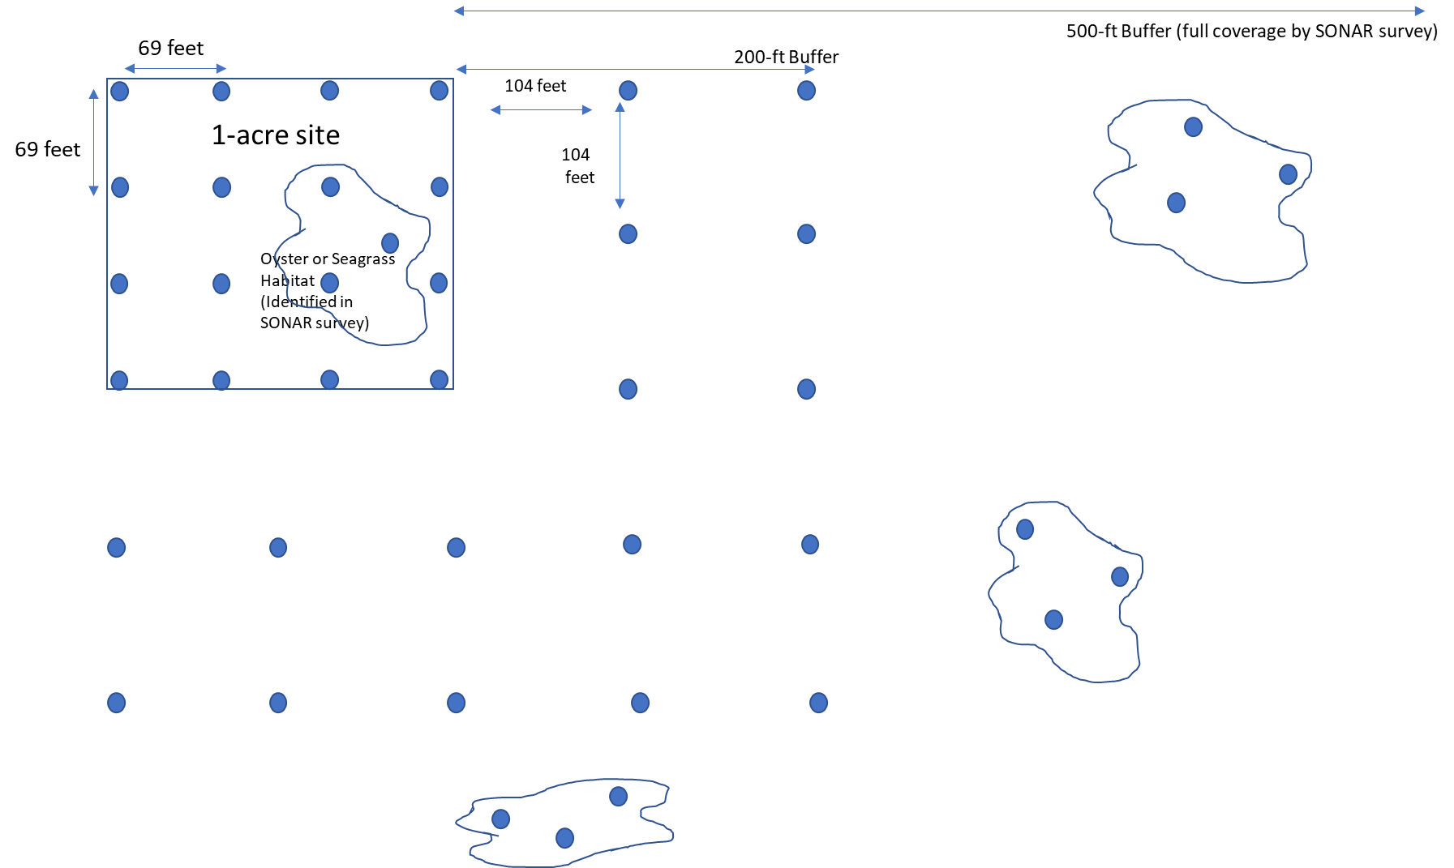
Figure 1-Sample spacing for ground-truthing SONAR surveys. Sixteen (16) samples per acre should be collected within the proposed permit site area, with samples collected every 69’ along transects that are spaced 69’ apart. In a 200’ buffer area around the proposed site, nine (9) samples should be collected per acre, with a sample every 104’ along transects that are spaced 104’ apart. Between the 200’ buffer area and 500’ buffer area, only features that are identified in the sidescan need to be verified with 3 in-situ samples per acre per feature.

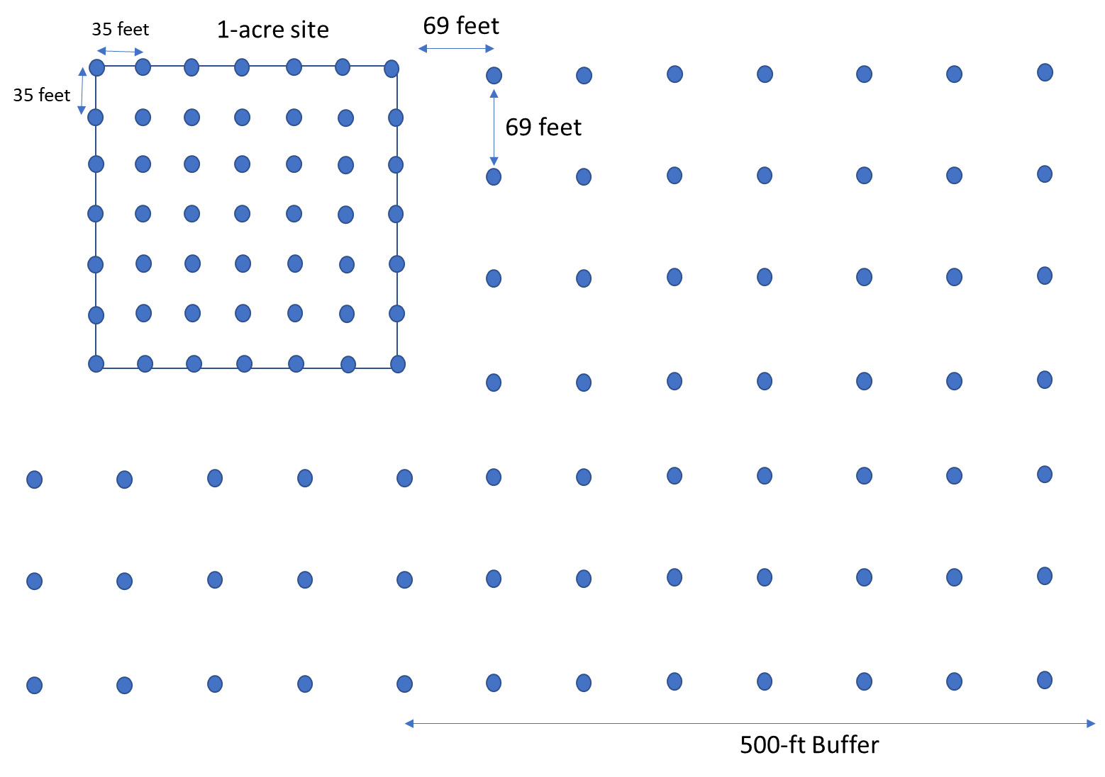
Figure 2- Sample spacing for in-situ surveys. Fifty (50) samples per acre should be collected within the proposed permit site area, with samples collected every ~35’ along transects that are spaced 35’ apart. Sixteen (16) samples per acre should be collected within the 500-ft buffer area, with samples collected every 69’ along transects that are spaced 69’ apart.

Table 1. Colonial Waterbird species list
Pelicaniformes
American White Pelican | Pelecanus erythrorhynchos
Brown Pelican | Pelecanus occidentalis
Neotropic Cormorant | Phalacrocorax brasilianus
Wading Birds
Great Blue Heron | Ardea herodias
Great Egret | Ardea alba
Snowy Egret | Egretta thula
Reddish Egret | Egretta rufescens
Tricolored Heron | Egretta tricolor
Little Blue Heron | Egretta caerulea
White Ibis | Eudocimus albus
White-faced Ibis | Plegadis chihi
Glossy Ibis | Plegadis falcinellus
Roseate Spoonbill | Ajaia ajaja
Gulls, Terns, Skimmers
Laughing Gull | Larus atricilla
Caspian Tern | Sterna caspia
Royal Tern | Sterna maxima
Forster's Tern | Sterna forsteri
Least Tern | Sterna antillarum
Gull-billed Tern | Sterna nilotica
Sooty Tern | Sterna fuscata
Sandwich Tern | Sterna sandwicensis
Black Skimmer | Rynchops niger
Black-crowned Night-Heron | Nycticorax nycticorax
Yellow-crowned Night-Heron | Nyctanassa violacea
Shorebirds
American Oystercatcher | Haematopus palliatus
Inland/Other
Anhinga | Anhinga anhinga
Green Heron | Butorides virescens
Cattle Egret | Bubulcus ibis
Double-crested Cormorant | Phalacrocorax auritus
Black-necked Stilt | Himantopus mexicanus

Please return completed application to:
Permit Coordinator, Coastal Fisheries
Texas Parks and Wildlife Department
4200 Smith School Road Austin, Texas 78744.

To process your request more efficiently, you may email completed forms to
oyster.mariculture@tpwd.texas.gov

Texas Parks and Wildlife Department maintains the information collected through this form. With few exceptions, you are entitled to be informed about the information we collect. Under Sections 552.021 and 553.023 of the Texas Government Code, you are also entitled to receive and review the information. Under Section 559.004, you are also entitled to have this information corrected. For assistance call 512- 389-8119.

