 | Volunteer Services Tracking Sheet  Texas Parks & Wildlife Department  Landowner Incentive Program  1887 CR 324  Lincoln, TX 78948  512.924.6987  www.tpwd.state.tx.us/lip | 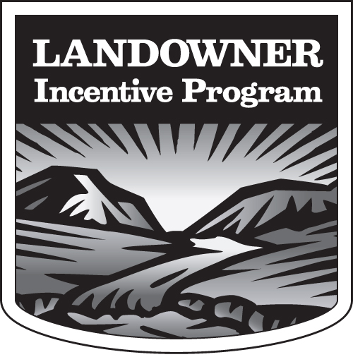

Project Title:
Project Manager:
Volunteer Organization:

Date(s) | Volunteer Name and Signature | Service Provided | Rate (not to exceed $10/hr) |  |  | Units (hours, acres) | Travel (0.5 X mi) | Total Match
Total >> |  |  |  |  |  |  |  | $
Validation of Services: I certify that the above services performed, time, and mileage are accurate and have been performed within the agreed time period of the grant awarded.
Grantee |  |  |  |  | Date
Project Manager |  |  |  |  | Date

